HANOI UNIVERSITY OF SCIENCE AND TECHNOLOGY

School of Information and Communications Technology

Software Design Document

Version 1.3

AIMS Software

Subject: ITSS Software Development

Group 08

Bui Hoang Ha 20205149

Do Hong Hai 20215199

Duong Hoang Hai 20215198

Nguyen Huu Hai 20215200

Dang Phuc Hieu 20194759

*Hanoi, June 2024*

Table of contents

Table of contents 1

1 Introduction 5

1.1 Objective 5

1.2 Scope 5

1.3 Glossary 5

1.4 References 6

2 Overall Description 7

2.1 General Overview 7

2.2 Assumptions/Constraints/Risks 7

2.2.1 Assumptions 7

2.2.2 Constraints 7

2.2.3 Risks 7

3 System Architecture and Architecture Design 9

3.1 Architectural Patterns 9

3.2 Interaction Diagrams 10

3.2.1 ViewOrderInformation 10

3.2.2 View List Product 10

3.2.3 View Detail Product 11

3.2.4 View Cart 11

3.2.5 Update Cart 12

3.2.6 Search Product 12

3.2.7 Place Order 13

3.2.8 Delete Product in Cart 13

3.2.9 Cancel Order 14

3.2.10 Add product to Cart 14

3.2.11 View list of orders 15

3.2.12 Approve order 16

3.2.13 Reject order 17

3.2.14 CRUD user 18

3.2.15 Manage User Role 19

3.2.16 Block/Unblock User 19

3.3 Analysis Class Diagrams 20

3.3.1 View Order Information 20

3.3.2 View List Product 20

3.3.3 View Detail Product 21

3.3.4 View Cart 21

3.3.5 Update Cart 22

3.3.6 Search Product 23

3.3.7 Place Order 24

3.3.8 Delete item in Cart 25

3.3.9 Cancel Order 26

3.3.10 Add Product to Cart 27

3.3.11 View list of orders 27

3.3.12 Approve order 28

3.3.13 Reject order 28

3.3.14 CRUD Users 29

3.3.15 Manage User Role 29

3.3.16 Block/Unblock User 30

3.4 Unified Analysis Class Diagram 31

3.4.1 Use case related to Order 31

3.4.2 Use case related to Product 32

3.4.3 Use cases related to manage orders 32

3.4.4 Use cases related to manage users 33

3.5 Security Software Architecture 33

4 Detailed Design 35

4.1 User Interface Design 35

4.1.1 Screen Configuration Standardization 35

4.1.2 Screen Transition Diagrams 35

4.1.3 Screen Specifications 35

4.2 Data Modeling 43

4.2.1 Conceptual Data Modeling 43

4.2.2 Database Design 45

4.2.2.1 Database Management System 45

4.2.2.2 Database Diagram 45

4.2.2.3 Database Detail Design 45

4.3 Non-Database Management System Files 51

4.3.1 Configuration File 51

4.3.1.1 Description and Usage: 51

4.3.1.2 File Structure: 51

4.4 Class Design 52

4.4.1 General Class Diagram 52

4.4.2 Class Diagrams 53

4.4.2.1 Class Diagram for Package common 53

4.4.2.2 Class Diagram for Package configs 53

4.4.2.3 Class Diagram for Package controller 54

4.4.2.4 Class Diagram for Package model 54

4.4.2.5 Class Diagram for Package exception 56

4.4.2.6 Class Diagram for Package repository 60

4.4.2.7 Class Diagram for Package service 61

4.4.2.8 Class Diagram for Package subsystem 61

4.4.3 Class Design 63

4.4.3.1 Class “OrderService” 63

4.4.3.2 Class “UserService” 65

4.4.3.3 Class “ProductService” 66

4.4.3.4 Class “DeliveryService” 68

4.4.3.5 Class “CartService” 69

4.4.3.6 Class “PaymentService” 71

4.4.3.7 Class “InvoiceService” 73

5 Design Considerations 75

5.1 Architecture Strategies 75

5.1.1 Backend Architecture: Spring Boot 75

5.1.2 Frontend Architecture: Next.js 75

5.1.3 Database System: MySQL 76

5.2 Goals and Guidelines 76

5.2.1 User-Friendly UI Design 76

5.2.2 Robust Backend Design 77

5.2.3 Reliable Database Design 77

5.3 Coupling and Cohesion 77

5.3.1 Coupling 77

5.3.2 Cohesion 81

5.4 Design Principles 82

5.5 Design Pattern 83

5.5.1 Strategy Pattern 83

5.5.2 Builder Pattern 86

# Introduction

The Software Design Document (SDD) for the AIMS provides a detailed blueprint for the design and architecture of the desktop e-commerce software. AIMS is designed to facilitate efficient product management, user administration, and customer interaction within an e-commerce environment. This document outlines the system's functional requirements, design considerations, and implementation details necessary for the development team to effectively build and deploy the software.

## Objective

The purpose of this Software Design Document (SDD) is to define the architectural and design aspects of the AIMS software system comprehensively. It serves as a guide for developers, testers, project managers, and stakeholders involved in the development lifecycle. The SDD specifies the system's structure, components, interfaces, and their interactions to ensure alignment with functional requirements and business goals.

## Scope

* Software Product(s): AIMS Software that operates 24/7, allowing new users to easily familiarize themselves. This software can serve up to 1000 customers simultaneously without significanty reducing performance and can operate continuously for 300 hours without failure.
* Functionality

1. **Product Management:** Product managers can add, view, edit, or delete products.
2. **Administrator:** Administrators can create, view, update, delete, and reset passwords for users. They can also block or unblock users as necessary
3. **User:** Users (administrators and product managers) log in to access role-specific features and change passwords securely. User can add product to cart and place order with VNPay payment.

## Glossary

|  |  |  |  |  |
| --- | --- | --- | --- | --- |
| **No** | **Term** | **Explanation** | **Example** | **Note** |
| 1 | token | A piece of data created by the server, and contains the user's information, as well as a special token code that user can pass to the server with every method that supports authentication, instead of passing a username and password directly. | JSON Web Token (JWT) | Compact, URL-safe and usable especially in web browser single sign-on (SSO) context. |

## References

NONE

# Overall Description

## General Overview

The Advanced Inventory Management System (AIMS) is a desktop-based e-commerce software designed to streamline product management, user administration, and customer interaction within an e-commerce environment. AIMS operates continuously, supporting up to 1,000 concurrent users and maintaining optimal performance under varying loads. The system architecture follows a modular approach, facilitating scalability and robustness.

## Assumptions/Constraints/Risks

### Assumptions

Assumptions regarding the AIMS system include:

* Dependence on Java Runtime Environment (JRE) for cross-platform compatibility.
* Users possess basic computer literacy for navigating the system.
* Continued availability of external APIs for shipping integration.
* Stable network connectivity for real-time updates and transactions.

### Constraints

Constraints influencing AIMS design and implementation:

* **Performance Requirements:** The system must maintain a maximum response time of 2 seconds under normal conditions and 5 seconds during peak usage.
* **Security Requirements:** Compliance with data protection regulations necessitates robust encryption and access control measures.
* **Hardware Compatibility:** AIMS must operate within defined memory and processing constraints to ensure optimal performance on desktop environments.

### Risks

Potential risks associated with the AIMS system and their mitigation strategies include:

* **Technical Risks:** Integration complexities with external APIs may lead to delays; regular testing and fallback mechanisms mitigate these risks.
* **Security Risks:** Vulnerabilities in user authentication and data encryption require continuous monitoring and updates to ensure data integrity and confidentiality.
* **Operational Risks:** Server downtime or network failures could disrupt service; redundant systems and backup procedures are in place to minimize downtime and ensure continuity.

# System Architecture and Architecture Design

## Architectural Patterns

The architectural pattern chosen for the AIMS (Advanced Inventory Management System) project is the Back-End for Front-End (BFF) pattern, leveraging the capabilities of the Spring Boot framework.

**Back-End for Front-End (BFF) Pattern:** The AIMS project adopts the Back-End for Front-End architectural pattern to enhance modularity and flexibility in its design. This pattern involves creating dedicated backend services tailored to the needs of different client applications or user interfaces. In AIMS, distinct backend services are developed to support interactions between the desktop client application and the central server. Each service is optimized for specific user roles, such as regular users, product managers, and administrators, ensuring efficient data retrieval, processing, and presentation.

**Reasons for Choosing the BFF Pattern with Spring Boot:**

1. **Modularity and Flexibility:** Spring Boot's microservices architecture complements the BFF pattern by allowing independent development and deployment of backend services. Each service handles specific functionalities, promoting code reusability and easier maintenance.
2. **Performance Optimization:** The combination of Spring Boot and the BFF pattern enables optimized data fetching and processing tailored to different user interfaces. This approach minimizes unnecessary data transfers and enhances system responsiveness, crucial for handling concurrent user interactions and maintaining high performance.
3. **Security and Scalability:** Spring Boot provides robust security features, including authentication, authorization, and secure communication protocols, essential for protecting sensitive data in an e-commerce environment. The BFF pattern reinforces security by enforcing role-based access control (RBAC) and implementing specific security measures per backend service.
4. **Alignment with Spring Boot Framework:** Spring Boot simplifies the development of RESTful APIs and backend services with its convention-over-configuration approach and auto-configuration capabilities. It offers extensive support for integrating with databases, external services, and deployment environments, ensuring scalability and extensibility as the AIMS project evolves.
5. **Developer Productivity:** Spring Boot's comprehensive ecosystem of libraries, plugins, and tools enhances developer productivity by reducing boilerplate code and accelerating development cycles. This efficiency is beneficial for delivering new features and updates promptly while maintaining code quality and reliability.

By integrating the BFF pattern with Spring Boot in the AIMS project, we achieve a robust, scalable, and secure architecture that meets the specific requirements of an e-commerce application. This approach not only facilitates seamless frontend-backend communication but also supports future enhancements and scalability with minimal disruption.

## Interaction Diagrams

### ViewOrderInformation

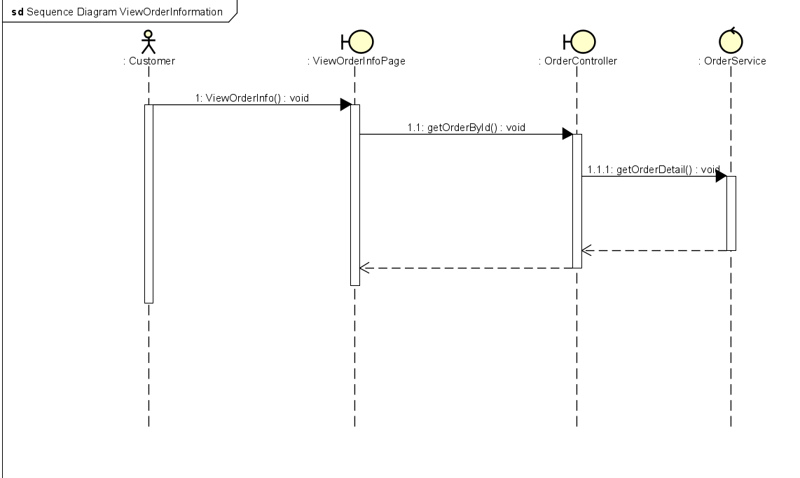

### View List Product

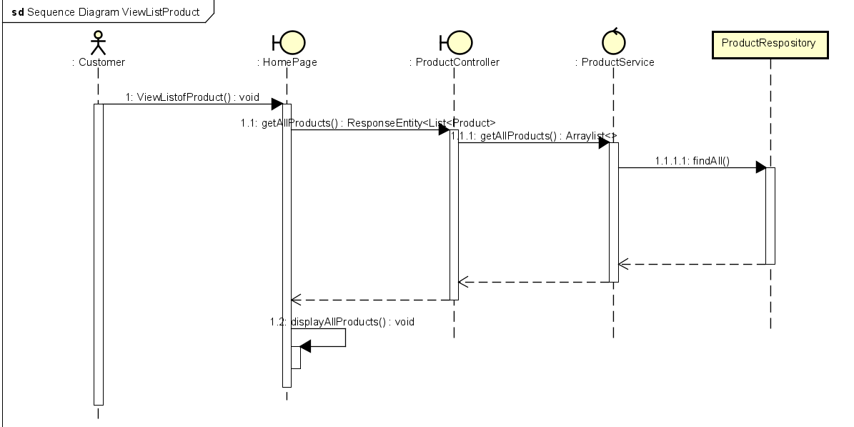

### View Detail Product

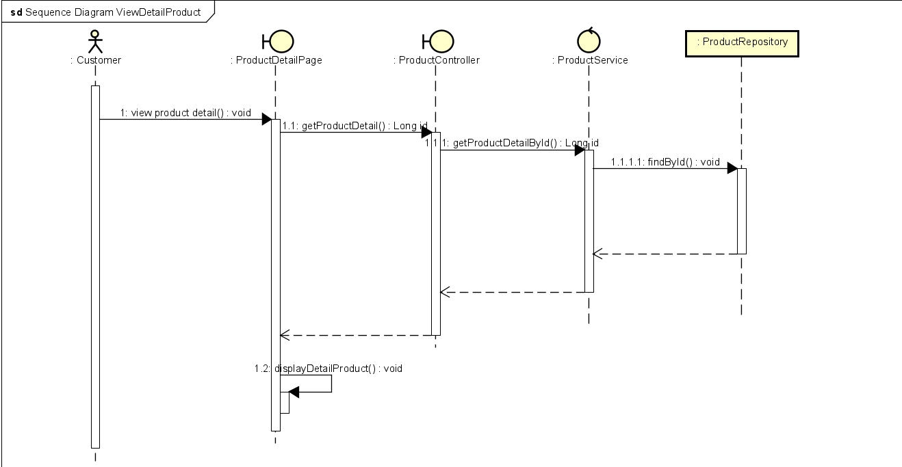

### View Cart

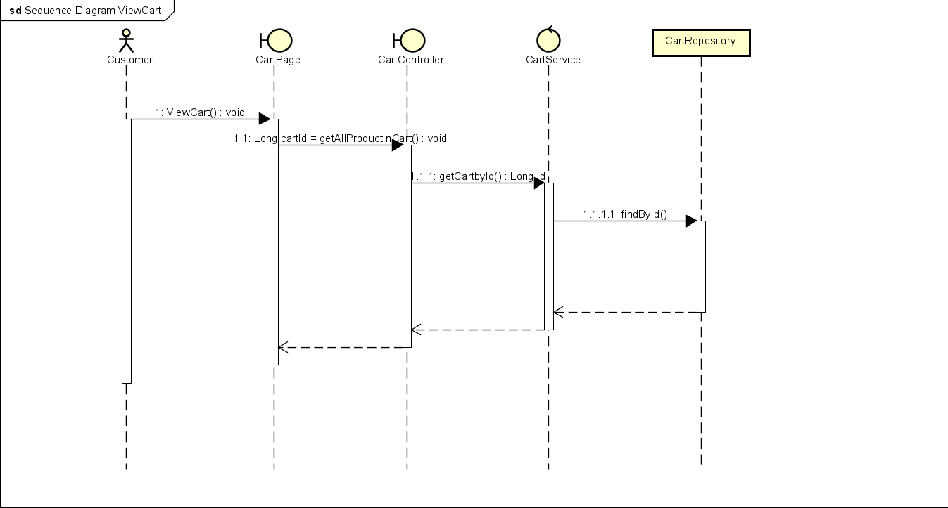

### Update Cart

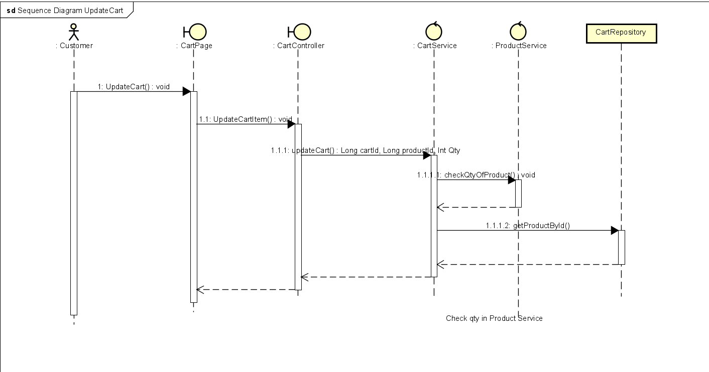

### Search Product

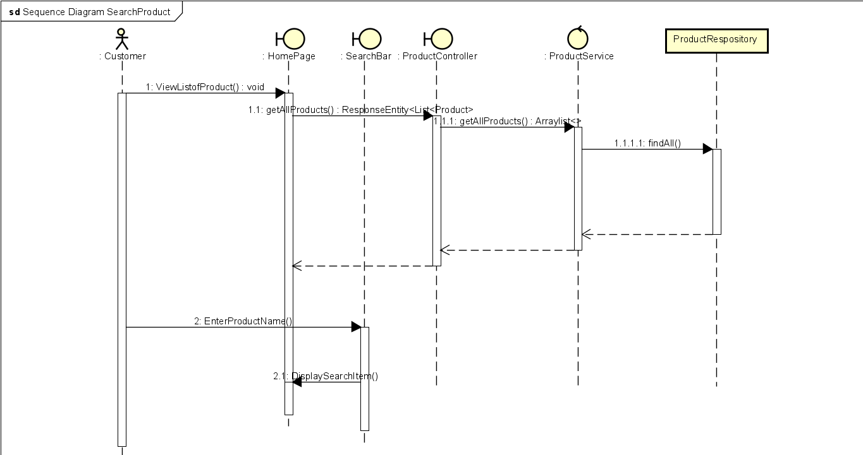

### Place Order

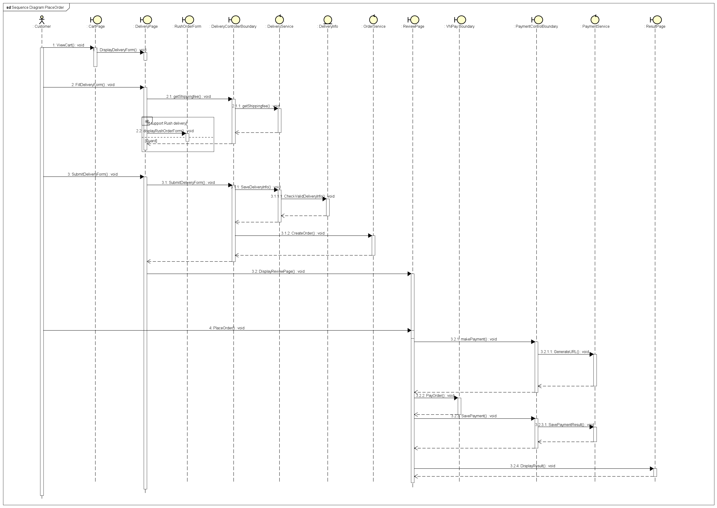

### Delete Product in Cart

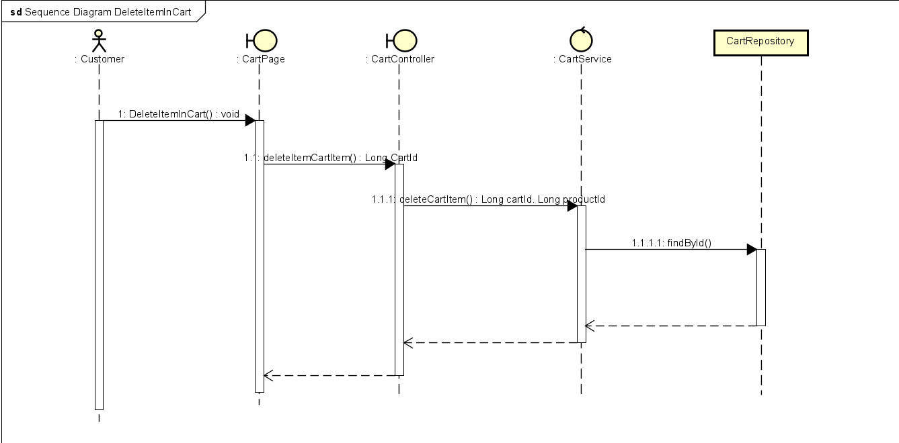

### Cancel Order

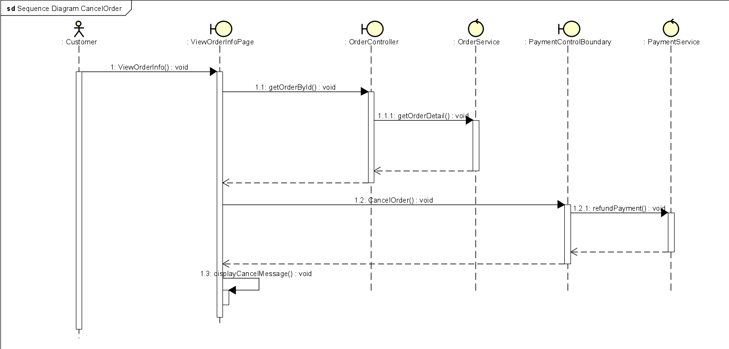

### Add product to Cart

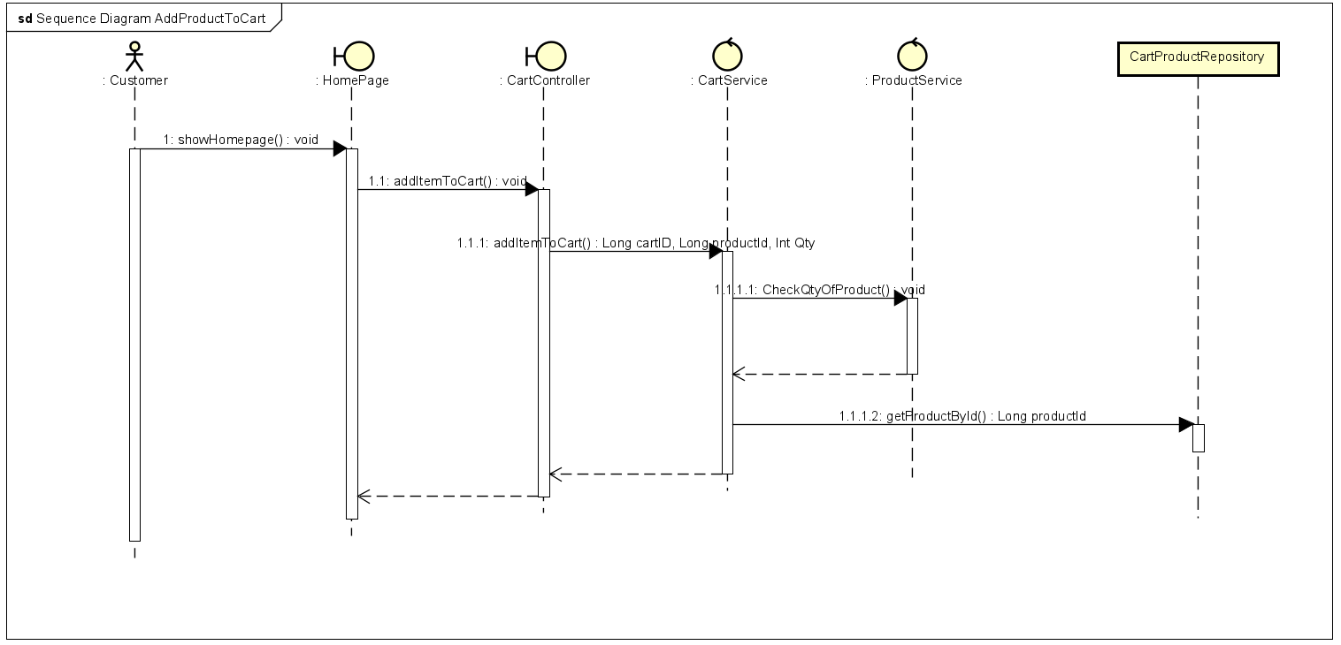

### View list of orders

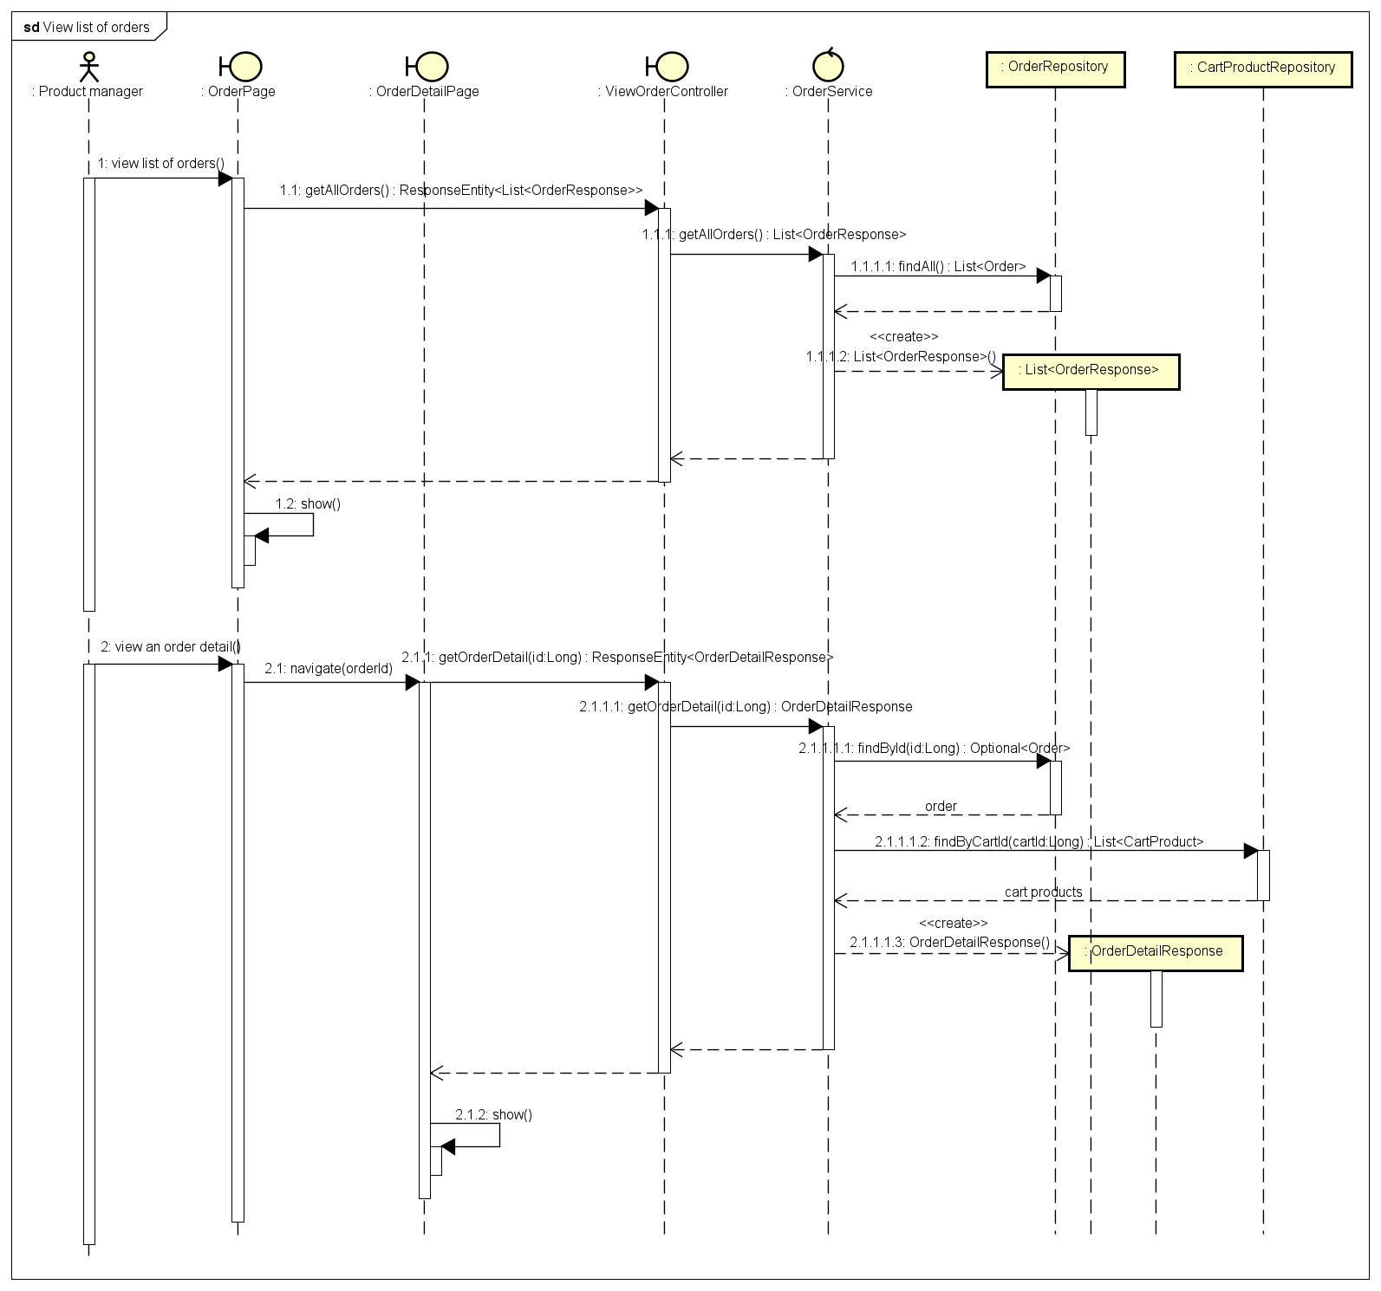

### Approve order

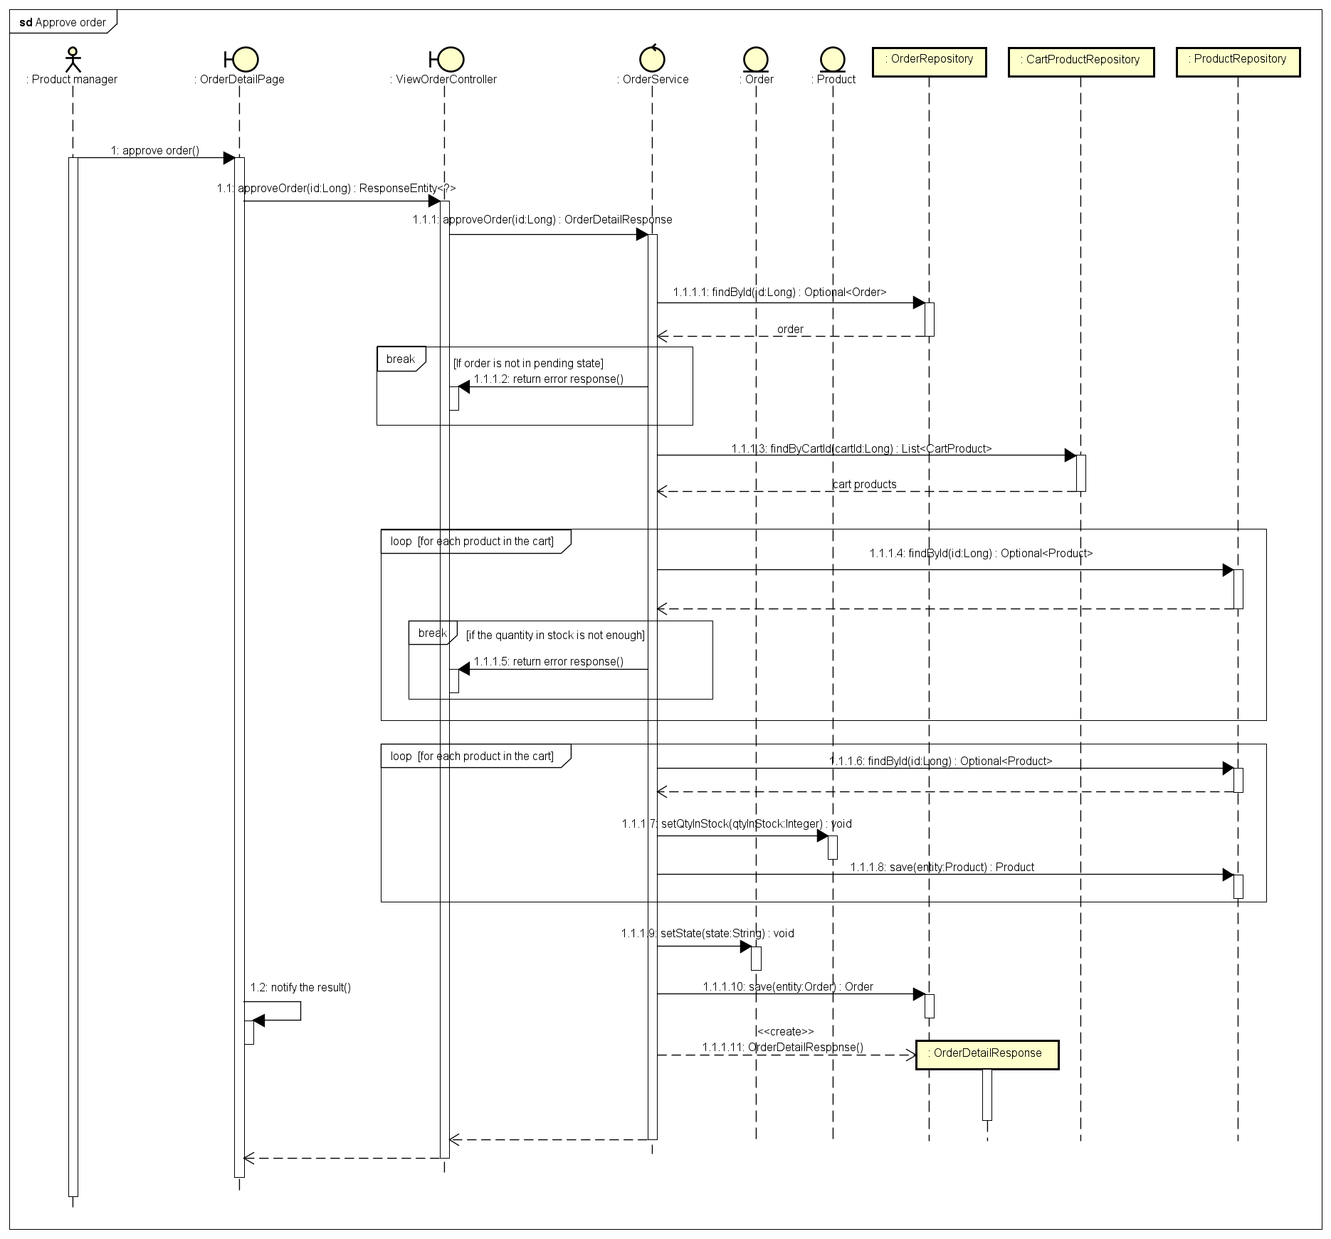

### Reject order

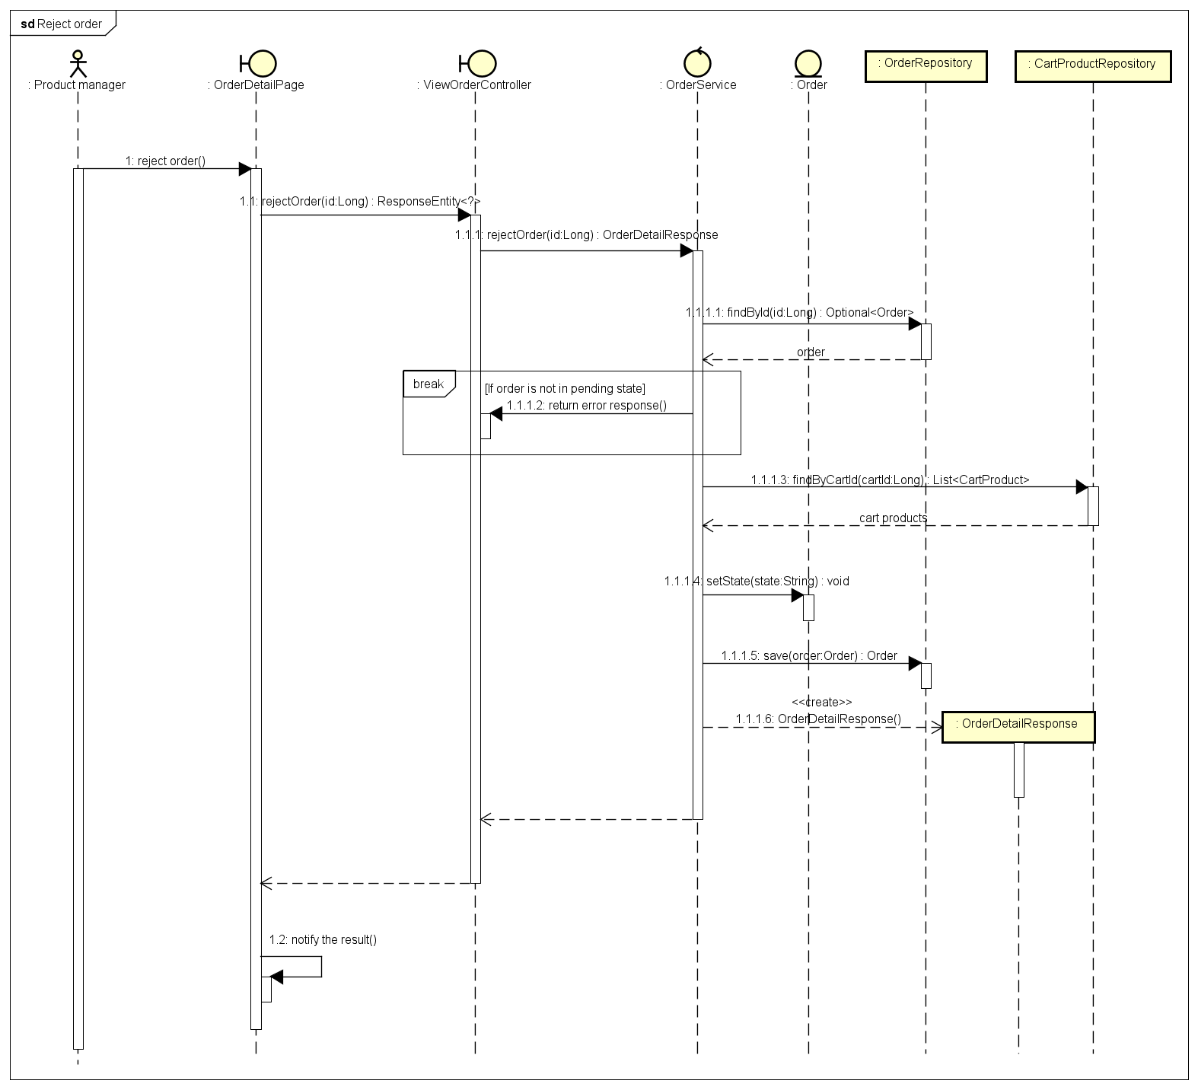

### CRUD user

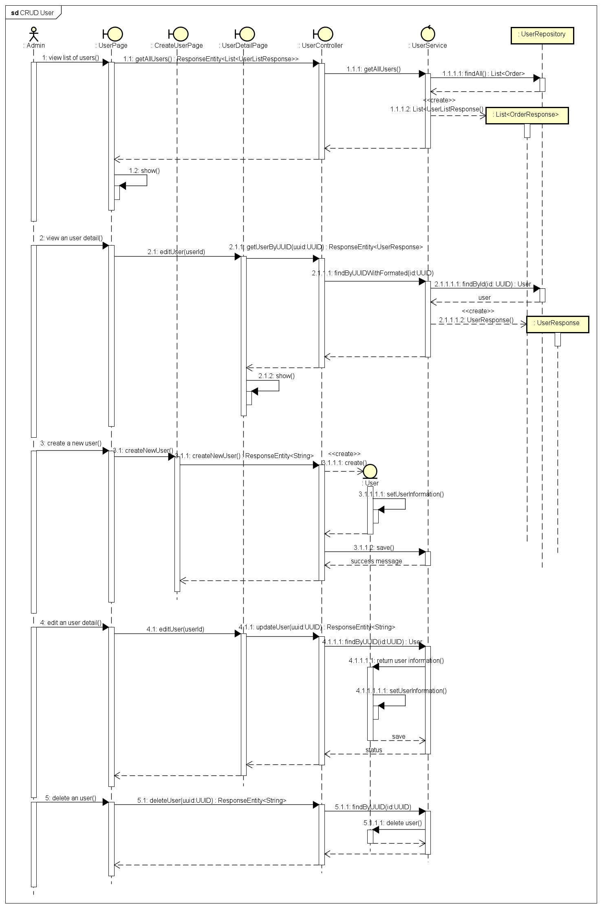

### Manage User Role

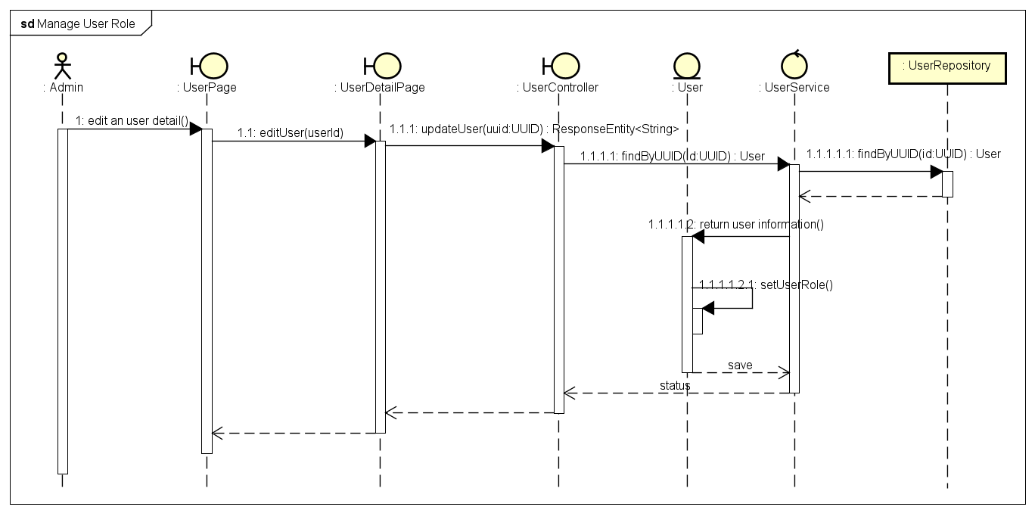

### Block/Unblock User

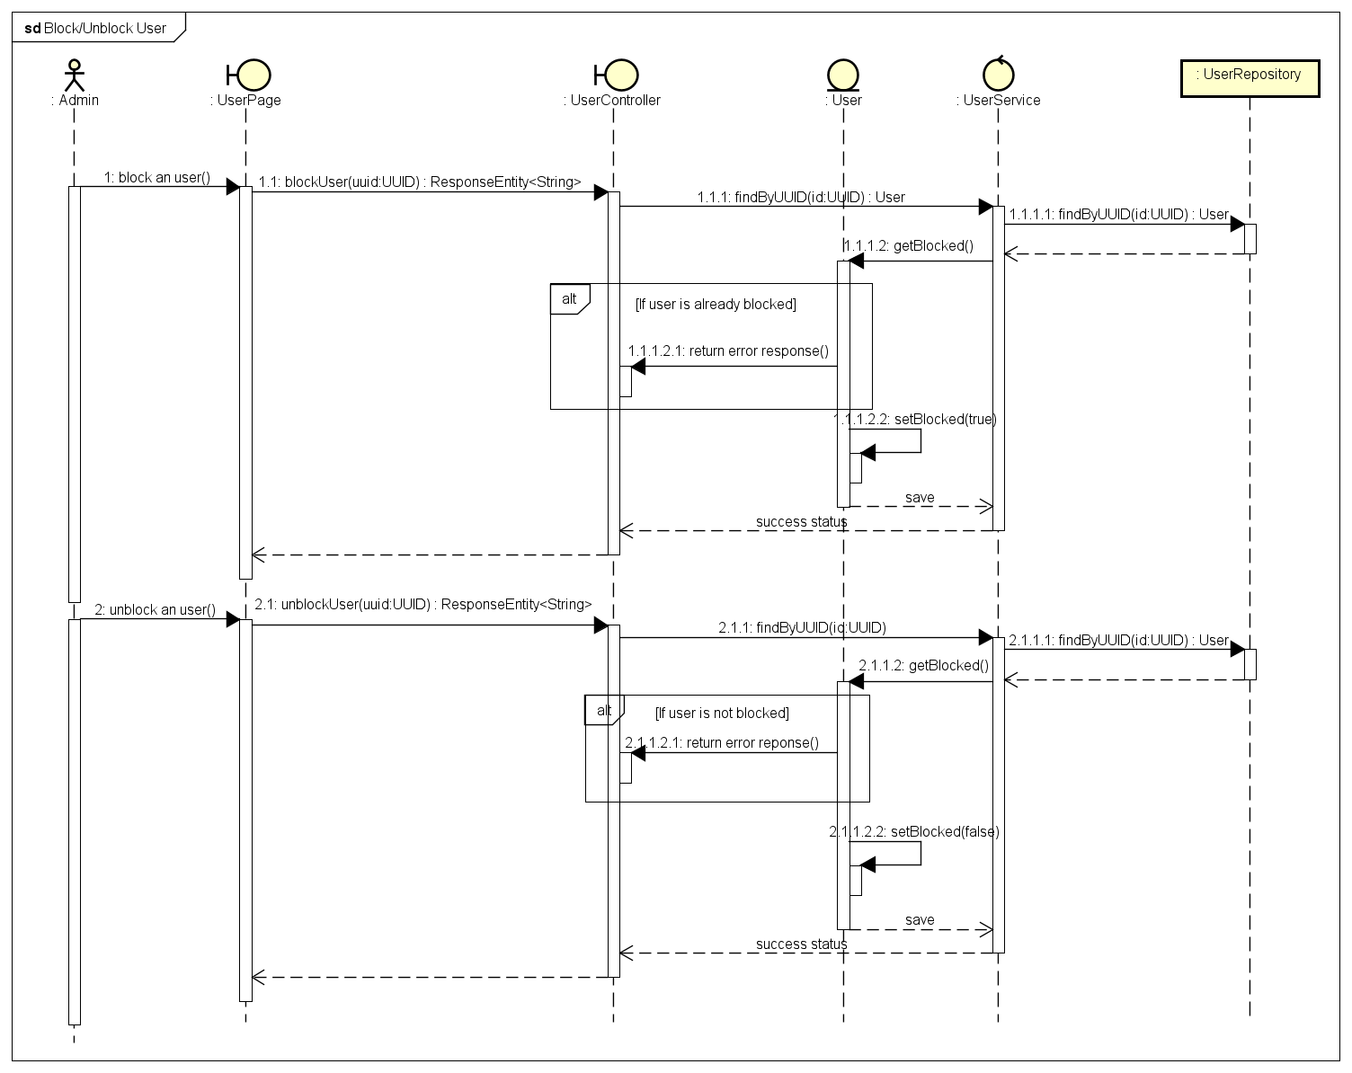

## Analysis Class Diagrams

### View Order Information

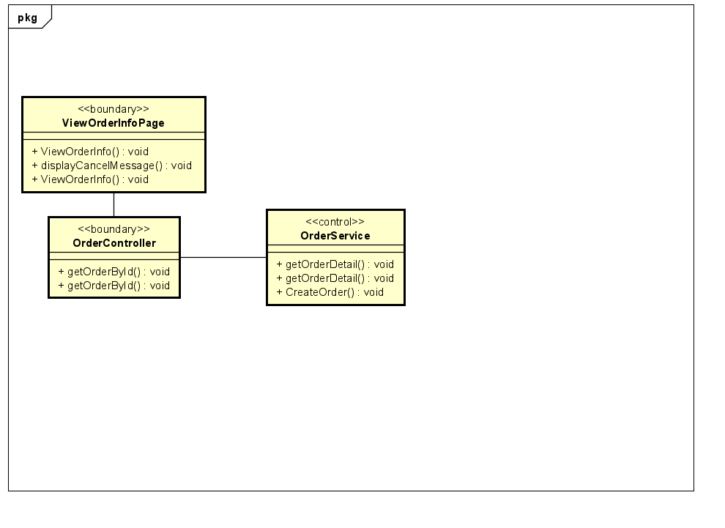

### View List Product

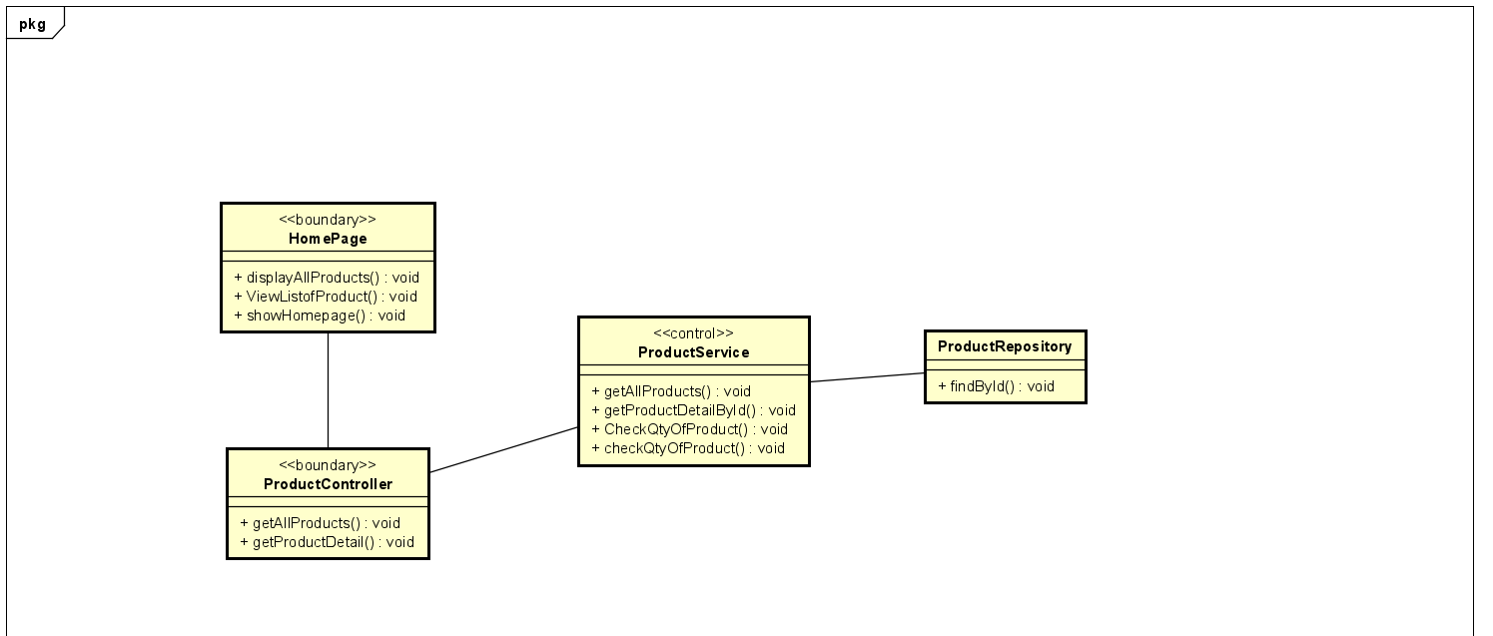

### View Detail Product

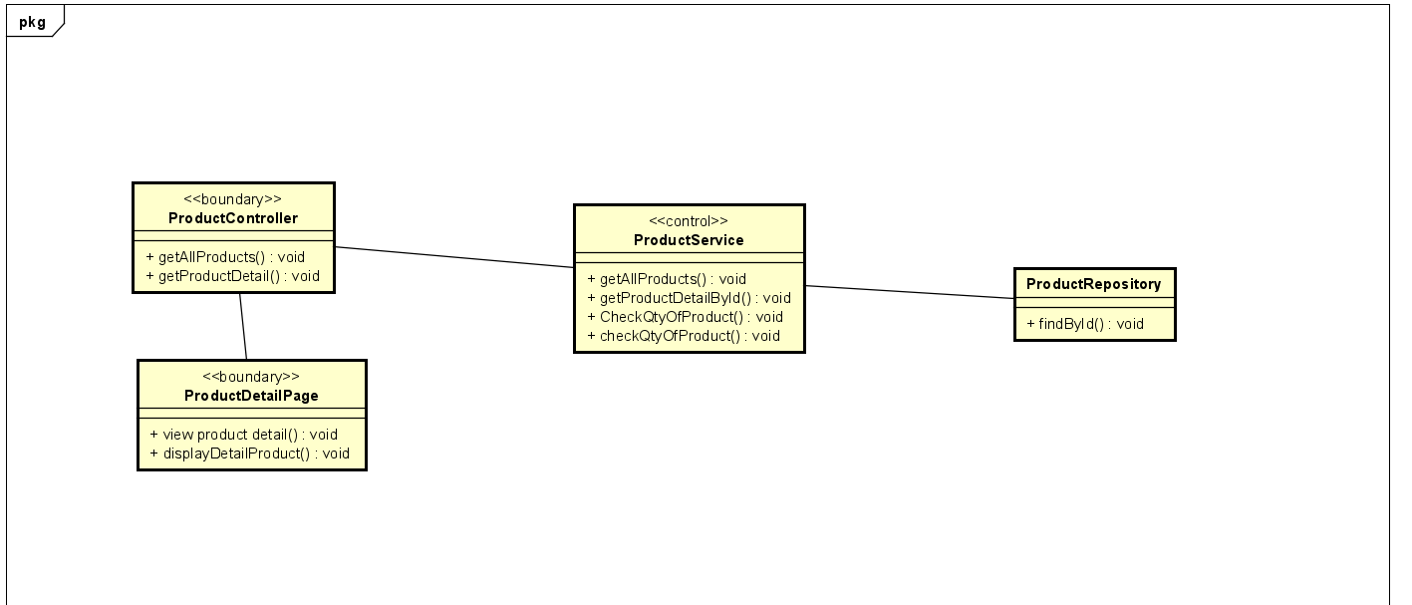

### View Cart

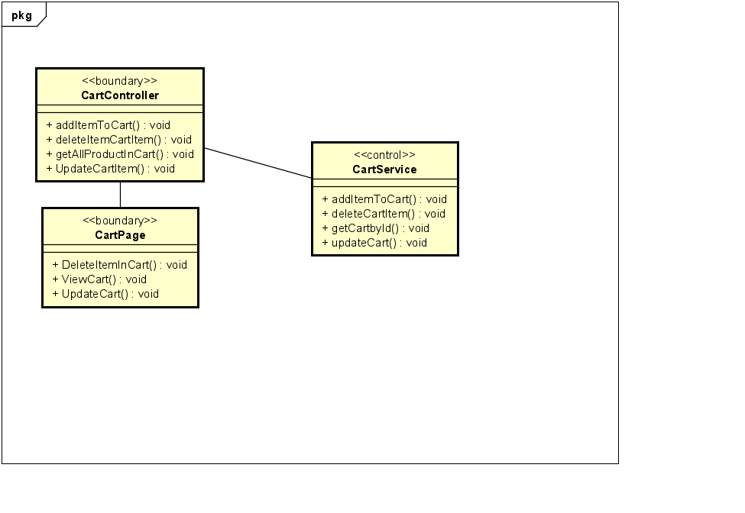

### Update Cart

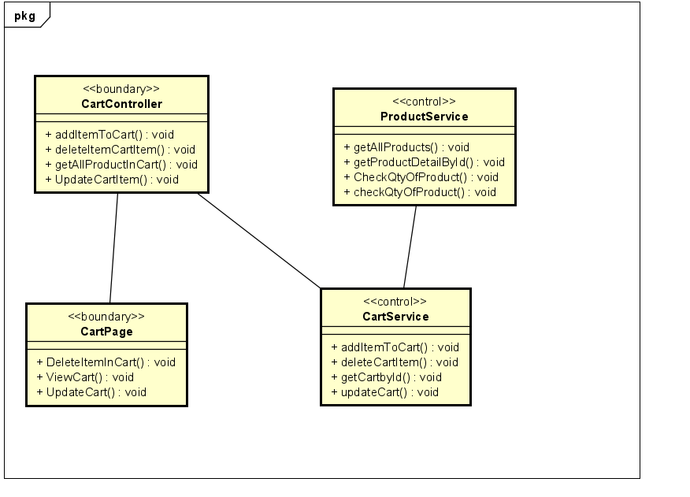

### Search Product

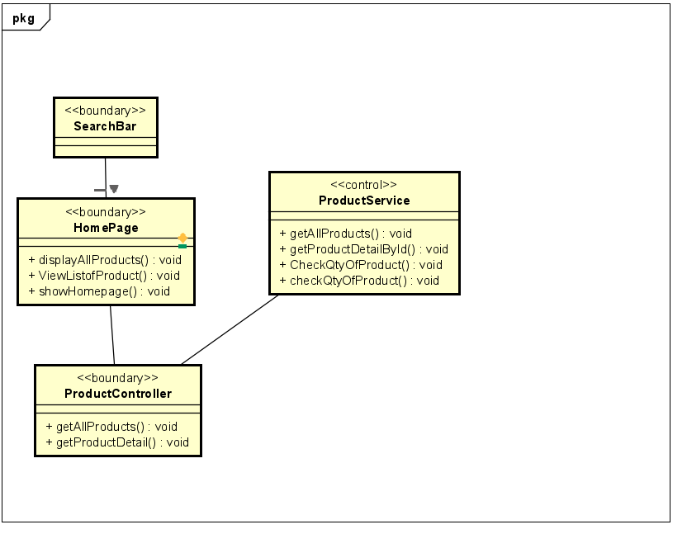

### Place Order

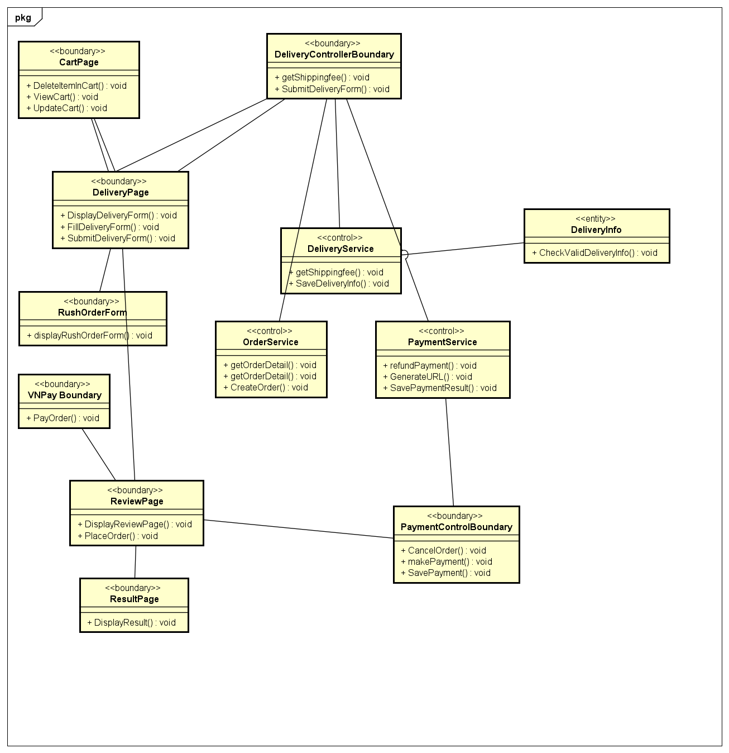

### Delete item in Cart

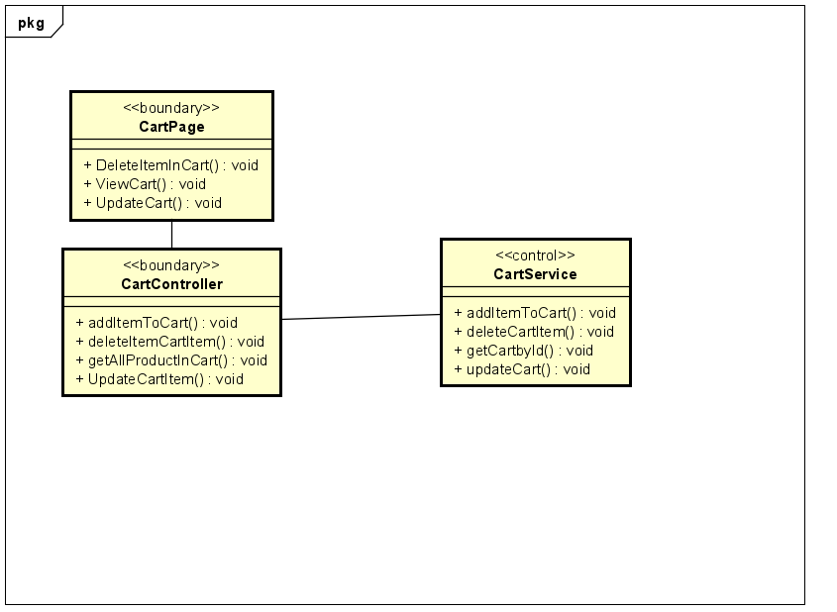

### Cancel Order

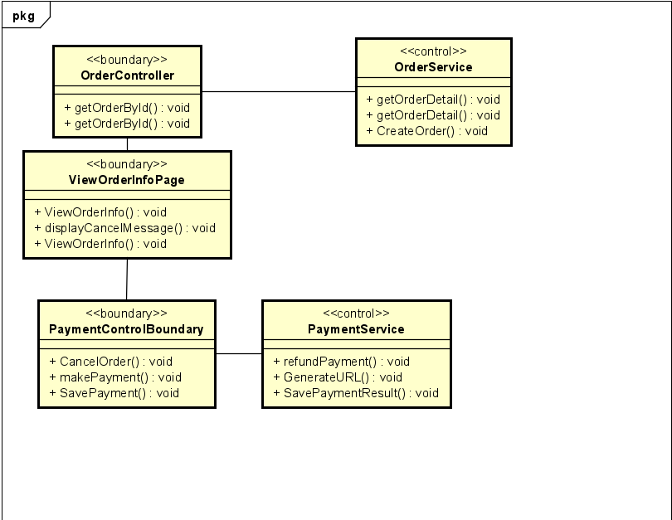

### Add Product to Cart

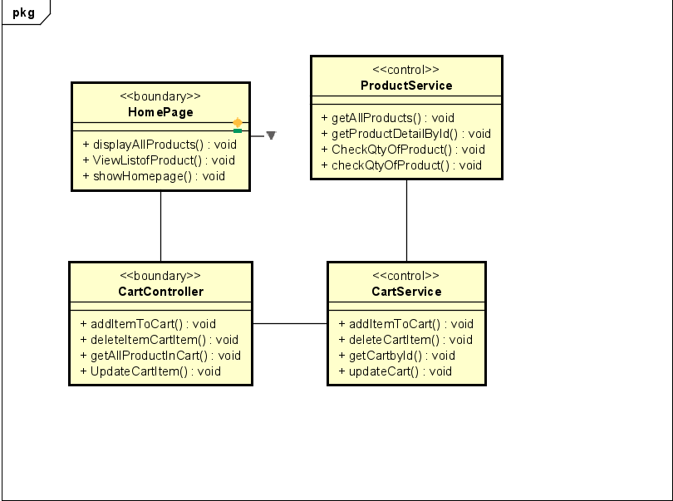

### View list of orders

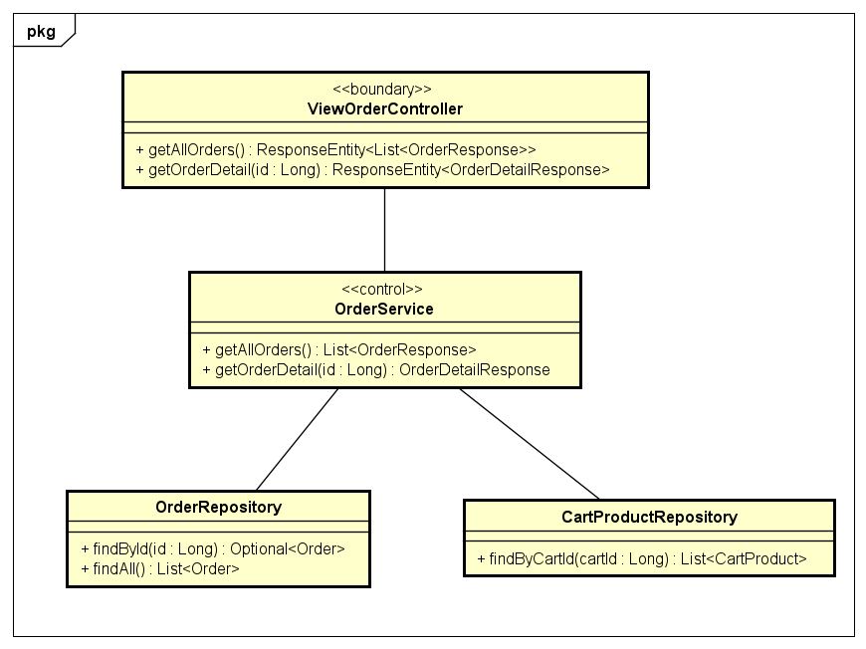

### Approve order

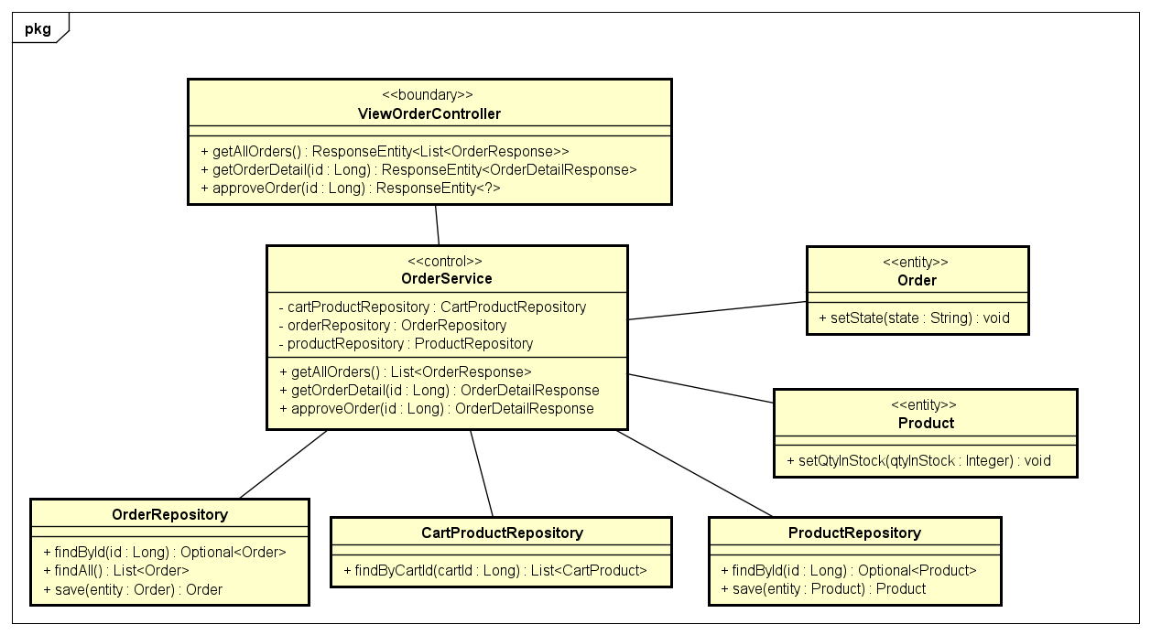

### Reject order

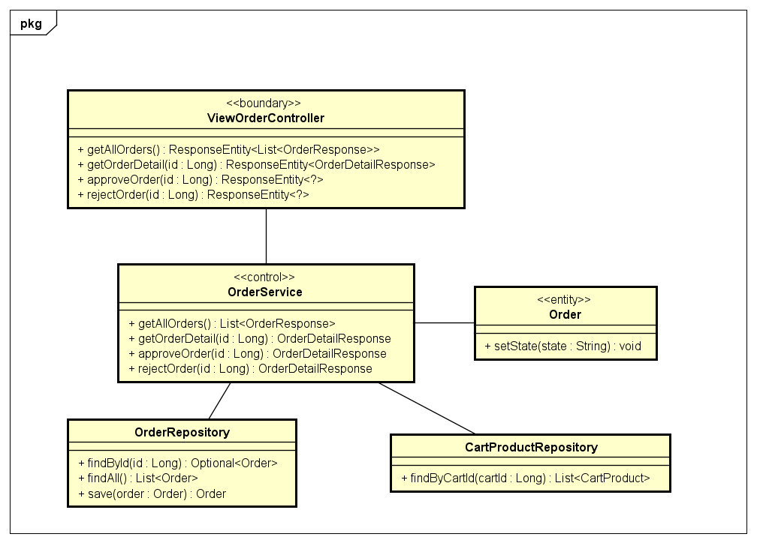

### CRUD Users

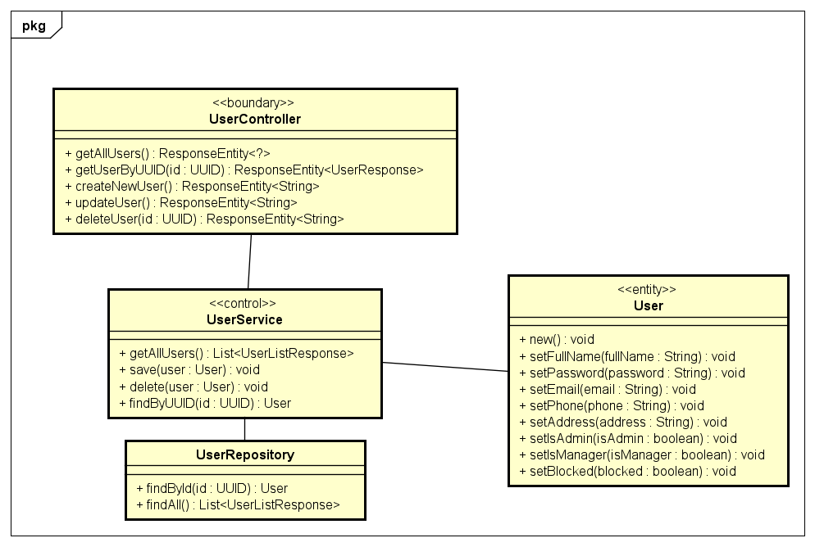

### Manage User Role

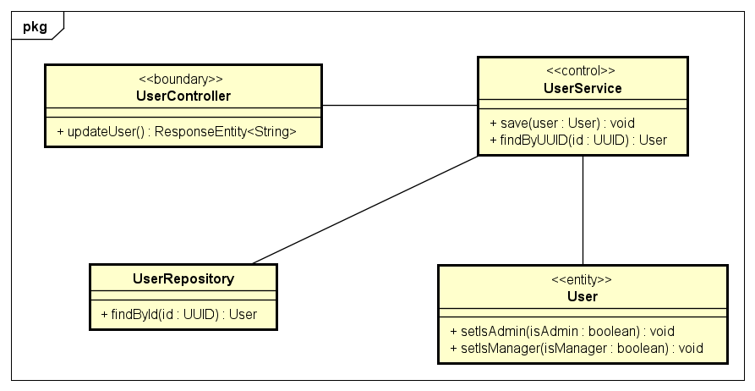

### Block/Unblock User

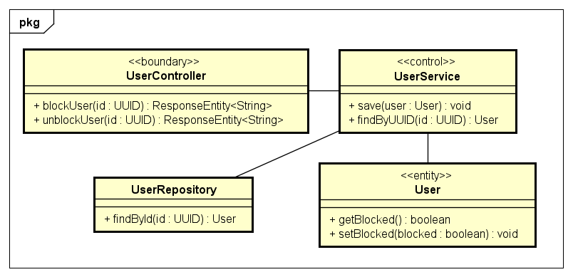

## Unified Analysis Class Diagram

### Use case related to Order

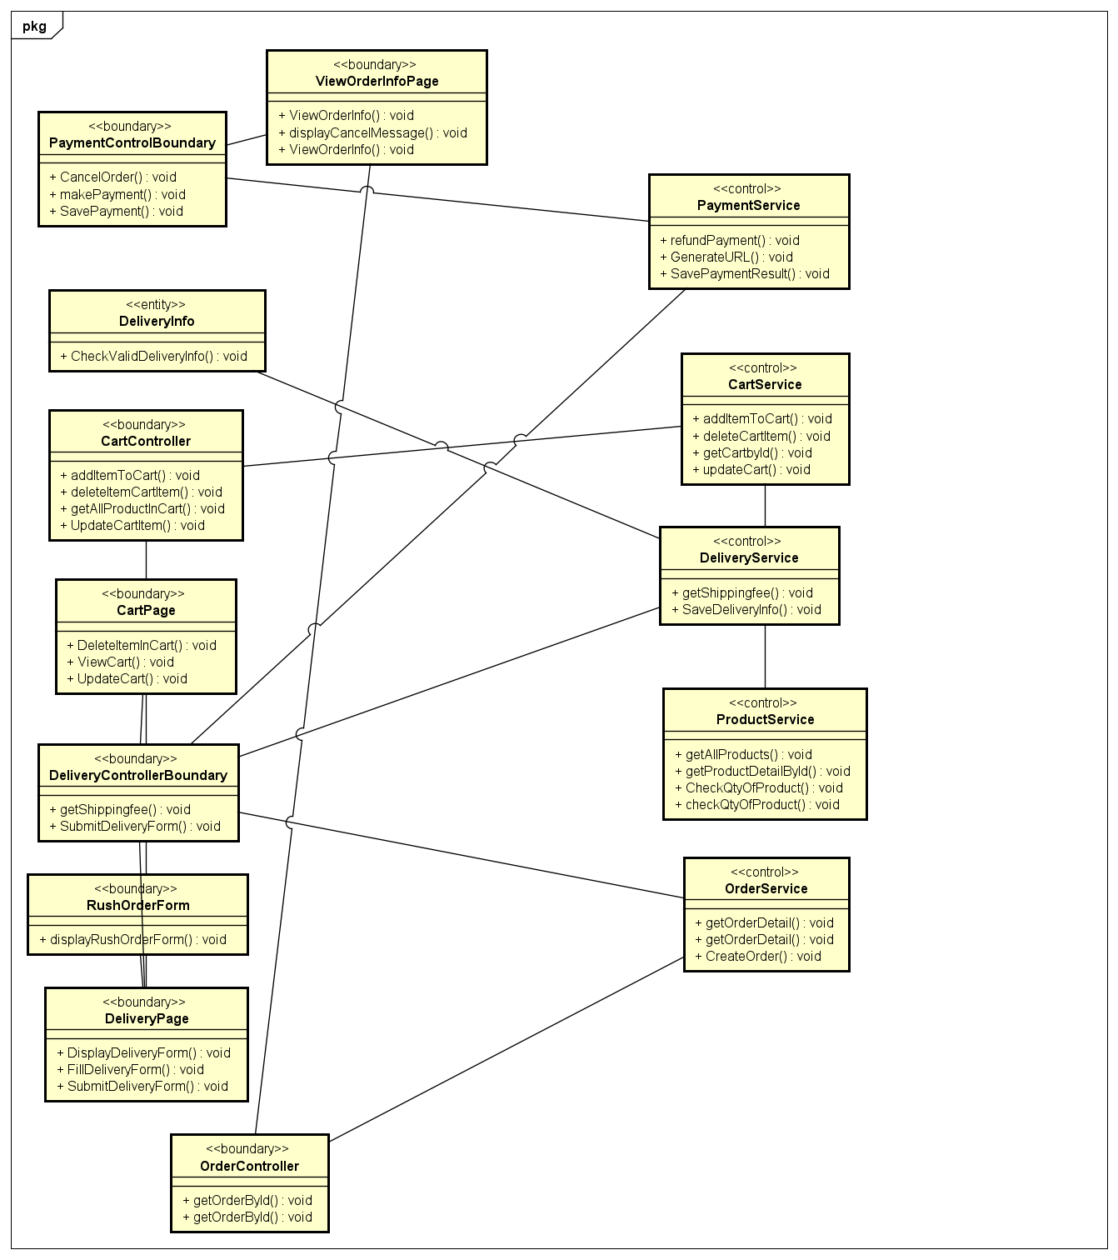

### Use case related to Product

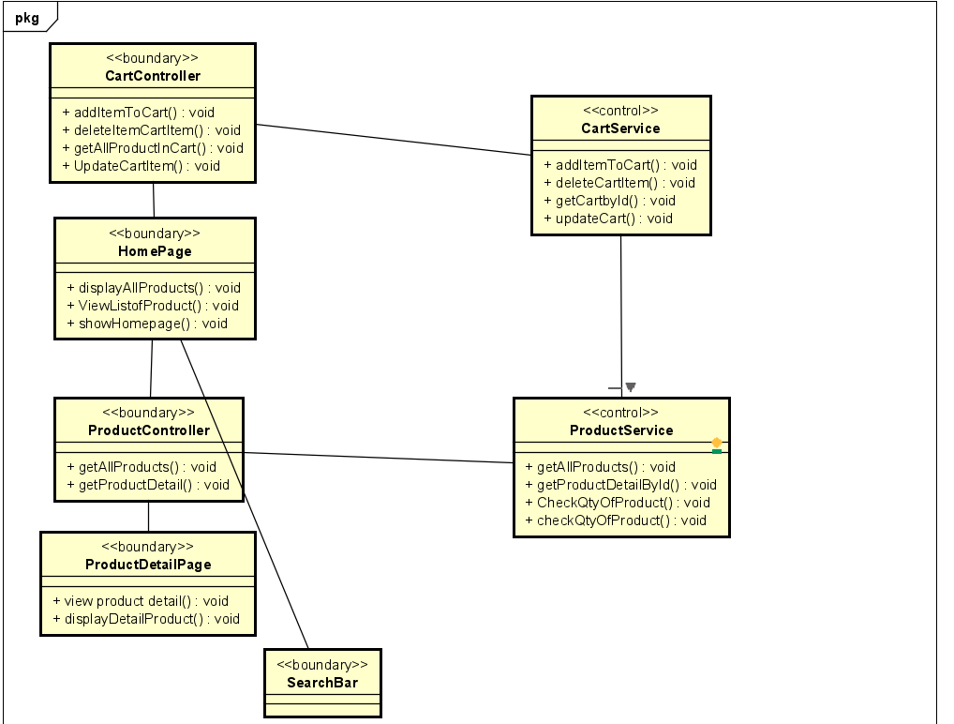

### Use cases related to manage orders

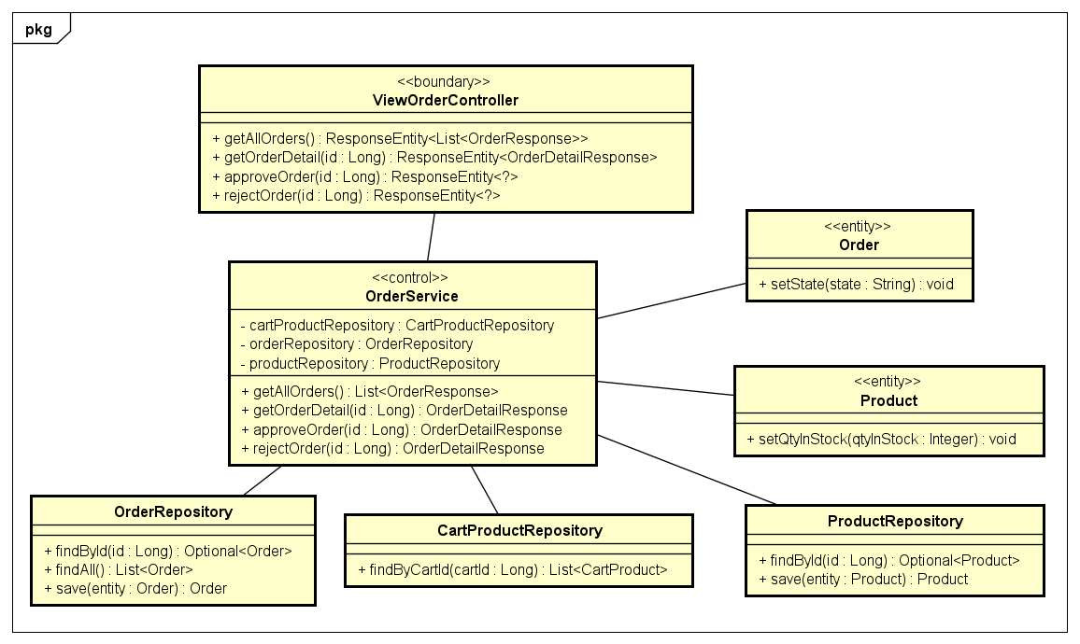

### Use cases related to manage users

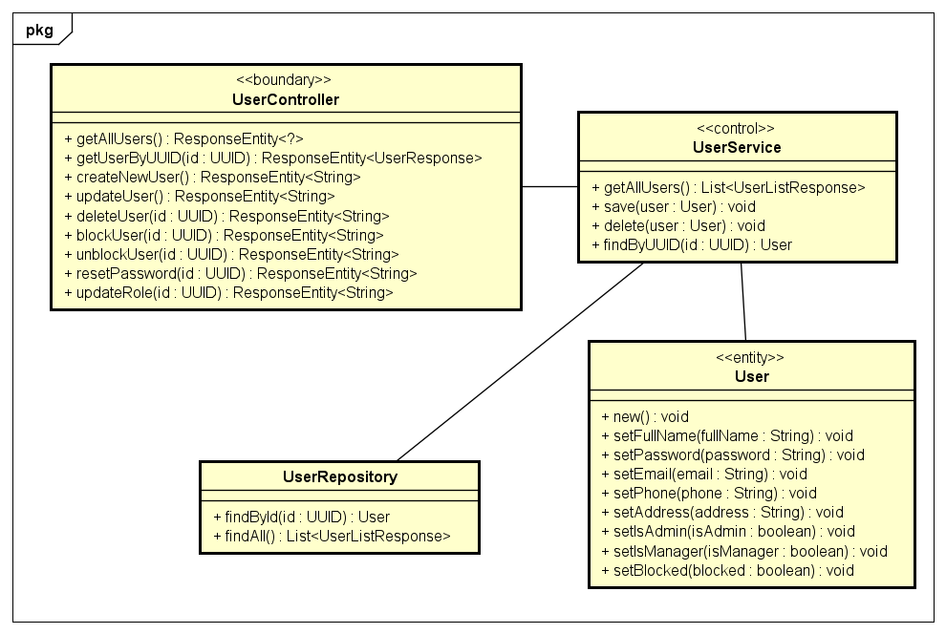

## Security Software Architecture

Our web application uses JSON Web Tokens (JWT) for authentication. JWT is an open standard (RFC 7519) that defines a compact and self-contained way for securely transmitting information between parties as a JSON object. The authentication process works as follows:

* When a user logs in with valid credentials, the server generates a JWT token consisting of three parts: a header, a payload, and a signature.
* The header contains the algorithm used for signing the token (e.g., HMAC SHA256 or RSA).
* The payload contains the user's identifying information, such as user ID, email, and any other relevant claims.
* The signature is created by encoding the header and payload with a secret key known only to the server.
* The generated JWT token is sent back to the client (typically in an HTTP response header or body).
* For subsequent requests, the client includes the JWT token in the Authorization header.
* The server verifies the token's signature using the same secret key, ensuring the token's integrity and authenticity.

Authorization of users to perform functional activity once logged into the system: After successful authentication, the JWT payload contains the user's claims and permissions. These claims are used to authorize access to specific routes, resources, or functionalities within the application. Authorization rules are defined and enforced on the server-side based on the user's claims extracted from the JWT token.

Encryption protocol to support the business risks and the nature of information: To protect sensitive data in transit, our application uses Transport Layer Security (TLS) protocol, also known as HTTPS. TLS provides end-to-end encryption between the client and server, preventing eavesdropping and man-in-the-middle attacks. Additionally, any sensitive data stored on the server is encrypted using industry-standard encryption algorithms like AES-256.

Logging and auditing design: Our application maintains detailed logs of user activities, including authentication events, authorization decisions, and any critical operations performed by users. These logs are stored securely and can be used for auditing purposes, troubleshooting, and security incident investigations.

The logging system captures relevant information such as:

* User ID and IP address
* Timestamp of the event
* Type of event (e.g., login, logout, access attempt, resource modification)
* Success or failure status
* Additional contextual information (e.g., requested resource, HTTP method, user agent)

Logs are periodically rotated and archived for long-term retention. Access to the logs is restricted to authorized personnel, and logs are regularly analyzed for potential security incidents or anomalies.

Additionally, our application adheres to industry best practices for secure coding, input validation, and handling of sensitive data. Regular security audits and penetration testing are conducted to identify and mitigate potential vulnerabilities.

# Detailed Design

## User Interface Design

### Screen Configuration Standardization

Display:

- Number of colors supported: 16,777,216 colors

- Resolution: 1920 x 1080 pixels

### Screen Transition Diagrams

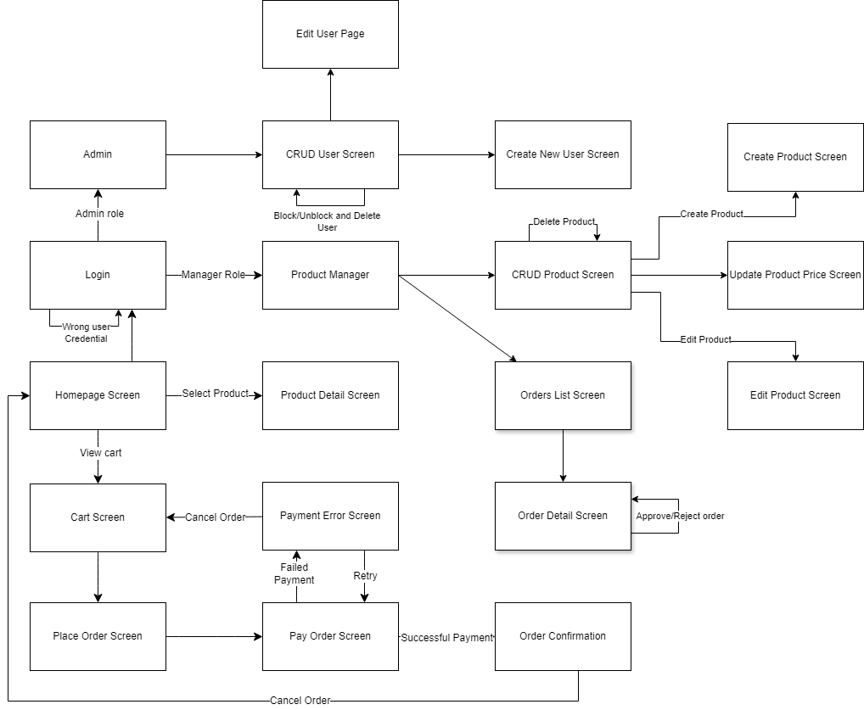

### Screen Specifications

|  |  |  |  |  |  |
| --- | --- | --- | --- | --- | --- |
| **AIMS Software** | | **Date of creation** | **Approved by** | **Reviewed by** | **Person in charge** |
| Screen specification | Order Page | 01/06/2024 |  |  | Dương Hoàng Hải |
|  | | **Control** | **Operation** | **Function** | |
| Area for displaying list of orders | Initial | Displays list of orders in the system | |
| “View order detail” button | Click | Allows users to view order details | |
| “Manager”  button | Click | Allows users to return to the home management page | |

|  |  |  |  |  |  |
| --- | --- | --- | --- | --- | --- |
| **AIMS Software** | | **Date of creation** | **Approved by** | **Reviewed by** | **Person in charge** |
| Screen specification | Order Detail Page | 01/06/2024 |  |  | Dương Hoàng Hải |
|  | | **Control** | **Operation** | **Function** | |
| Area for displaying the delivery information | Initial | Display detail delivery information | |
| Area for displaying the products | Initial | Display list of products in the order | |
| Area for displaying the shipping fess & Total amount | Inital | Display shipping fees, total amount and state of the order | |
| “Approve order” button | Click | Approve this order | |
| “Reject order” button | Click | Reject this order | |

|  |  |  |  |  |  |
| --- | --- | --- | --- | --- | --- |
| **AIMS Software** | | **Date of creation** | **Approved by** | **Reviewed by** | **Person in charge** |
| Screen specification | User Page | 01/06/2024 |  |  | Dương Hoàng Hải |
|  | | **Control** | **Operation** | **Function** | |
| **Control** | **Operation** | **Function** | |
| Area for displaying list of users | Initial | Displays list of users in the system | |
| “Edit user” button | Click | Allows admin to view user details | |
| “Delete user” button | Click | Allows admin to delete user | |
| “Block user” button | Click | Allows admin to block user | |

|  |  |  |  |  |  |  |
| --- | --- | --- | --- | --- | --- | --- |
| **AIMS Software** | | **Date of creation** | | **Approved by** | **Reviewed by** | **Person in charge** |
| Screen specification | User Edit Page | 01/06/2024 | |  |  | Dương Hoàng Hải |
|  | | **Control** | | **Operation** | **Function** | |
| **Control** | | **Operation** | **Function** | |
| Area for displaying user detail fields | | Initial | Displays current information of selected user in each fields | |
| “Reset Password” button | Click | Allows admin to reset user password | | |
| “Update” button | | Click | Allows admin to update user detail | |

|  |  |  |  |  |  |
| --- | --- | --- | --- | --- | --- |
| **AIMS Software** | | **Date of creation** | **Approved by** | **Reviewed by** | **Person in charge** |
| Screen specification | Create New User Page | 01/06/2024 |  |  | Dương Hoàng Hải |
|  | | **Control** | **Operation** | **Function** | |
| **Control** | **Operation** | **Function** | |
| Area for displaying user detail fields | Initial | Displays null information of user in each field | |
| “Update” button | Click | Allows admin to update user detail | |

|  |  |  |  |  |  |
| --- | --- | --- | --- | --- | --- |
| **AIMS Software** | | **Date of creation** | **Approved by** | **Reviewed by** | **Person in charge** |
| Screen specification | View List Products Page | 01/06/2024 |  |  | Nguyễn Hữu Hải |
|  | | **Control** | **Operation** | **Function** | |
| **Control** | **Operation** | **Function** | |
| Area for displaying list of product page | Initital | Displays information about list of products. | |
| “Sort” button | Click | Allows user to sort item | |

|  |  |  |  |  |  |
| --- | --- | --- | --- | --- | --- |
| **AIMS Software** | | **Date of creation** | **Approved by** | **Reviewed by** | **Person in charge** |
| Screen specification | Search Page | 01/06/2024 |  |  | Nguyễn Hữu Hải |
|  | | **Control** | **Operation** | **Function** | |
| **Control** | **Operation** | **Function** | |
| Area for displaying list of product base on search result | Initital | Displays information about product that meet search requirement. | |
| “Search” bar | Control | Allows user to search item | |

|  |  |  |  |  |  |
| --- | --- | --- | --- | --- | --- |
| **AIMS Software** | | **Date of creation** | **Approved by** | **Reviewed by** | **Person in charge** |
| Screen specification | View Detail Product Page | 01/06/2024 |  |  | Nguyễn Hữu Hải |
|  | | **Control** | **Operation** | **Function** | |
| **Control** | **Operation** | **Function** | |
| Area for displaying detail product | Initital | Displays detail information about a product | |
| “View” detail button | Click | Allows user to view detail a product | |

|  |  |  |  |  |  |
| --- | --- | --- | --- | --- | --- |
| **AIMS Software** | | **Date of creation** | **Approved by** | **Reviewed by** | **Person in charge** |
| Screen specification | Add to cart Page | 01/06/2024 |  |  | Nguyễn Hữu Hải |
|  | | **Control** | **Operation** | **Function** | |
| **Control** | **Operation** | **Function** | |
| Area for displaying information of a product | Initital | Displays information about a product | |
| “Add to cart” button | Click | Allows user to add a product to their cart | |

|  |  |  |  |  |  |
| --- | --- | --- | --- | --- | --- |
| **AIMS Software** | | **Date of creation** | **Approved by** | **Reviewed by** | **Person in charge** |
| Screen specification | View Cart Page | 01/06/2024 |  |  | Nguyễn Hữu Hải |
|  | | **Control** | **Operation** | **Function** | |
| **Control** | **Operation** | **Function** | |
| Area for displaying information of a cart | Initital | Displays information about a cart | |
| “Cart” button | Click | Allows user to view their cart | |

|  |  |  |  |  |  |
| --- | --- | --- | --- | --- | --- |
| **AIMS Software** | | **Date of creation** | **Approved by** | **Reviewed by** | **Person in charge** |
| Screen specification | Update Cart Page | 01/06/2024 |  |  | Nguyễn Hữu Hải |
|  | | **Control** | **Operation** | **Function** | |
| **Control** | **Operation** | **Function** | |
| Area for displaying quantity of a product | Initital | Displays quantity of product | |
| “X” button | Click | Allows user to delete product from their cart | |
| “+” | Click | Allow user increase their quantity of product by 1 | |
| “-” | Click | Allow user decrease their quantity of product by 1 | |

|  |  |  |  |  |  |
| --- | --- | --- | --- | --- | --- |
| **AIMS Software** | | **Date of creation** | **Approved by** | **Reviewed by** | **Person in charge** |
| Screen specification | Order Tracking Page | 01/06/2024 |  |  | Nguyễn Hữu Hải |
|  | | **Control** | **Operation** | **Function** | |
| **Control** | **Operation** | **Function** | |
| Area for displaying information about status of user order | Initital | Displays information about status of user order | |
| “Track Order” button | Click | Allows user to enter order’s id | |

|  |  |  |  |  |  |
| --- | --- | --- | --- | --- | --- |
| **AIMS Software** | | **Date of creation** | **Approved by** | **Reviewed by** | **Person in charge** |
| Screen specification | Cancel Order Page | 01/06/2024 |  |  | Nguyễn Hữu Hải |
|  | | **Control** | **Operation** | **Function** | |
| **Control** | **Operation** | **Function** | |
| Area for displaying cancel order | Initital | Displays information about cancel of an order | |
| “Cancel Order” button | Click | Allows user to cancel their order | |

## Data Modeling

### Conceptual Data Modeling

Data modeling is the process of creating a visual representation of an entire information system or parts of it to convey the connections between data points and structures. The goal is to illustrate the types of data used and stored within the system, the relationships between these data types, how data can be grouped and organized, as well as its formats and attributes.

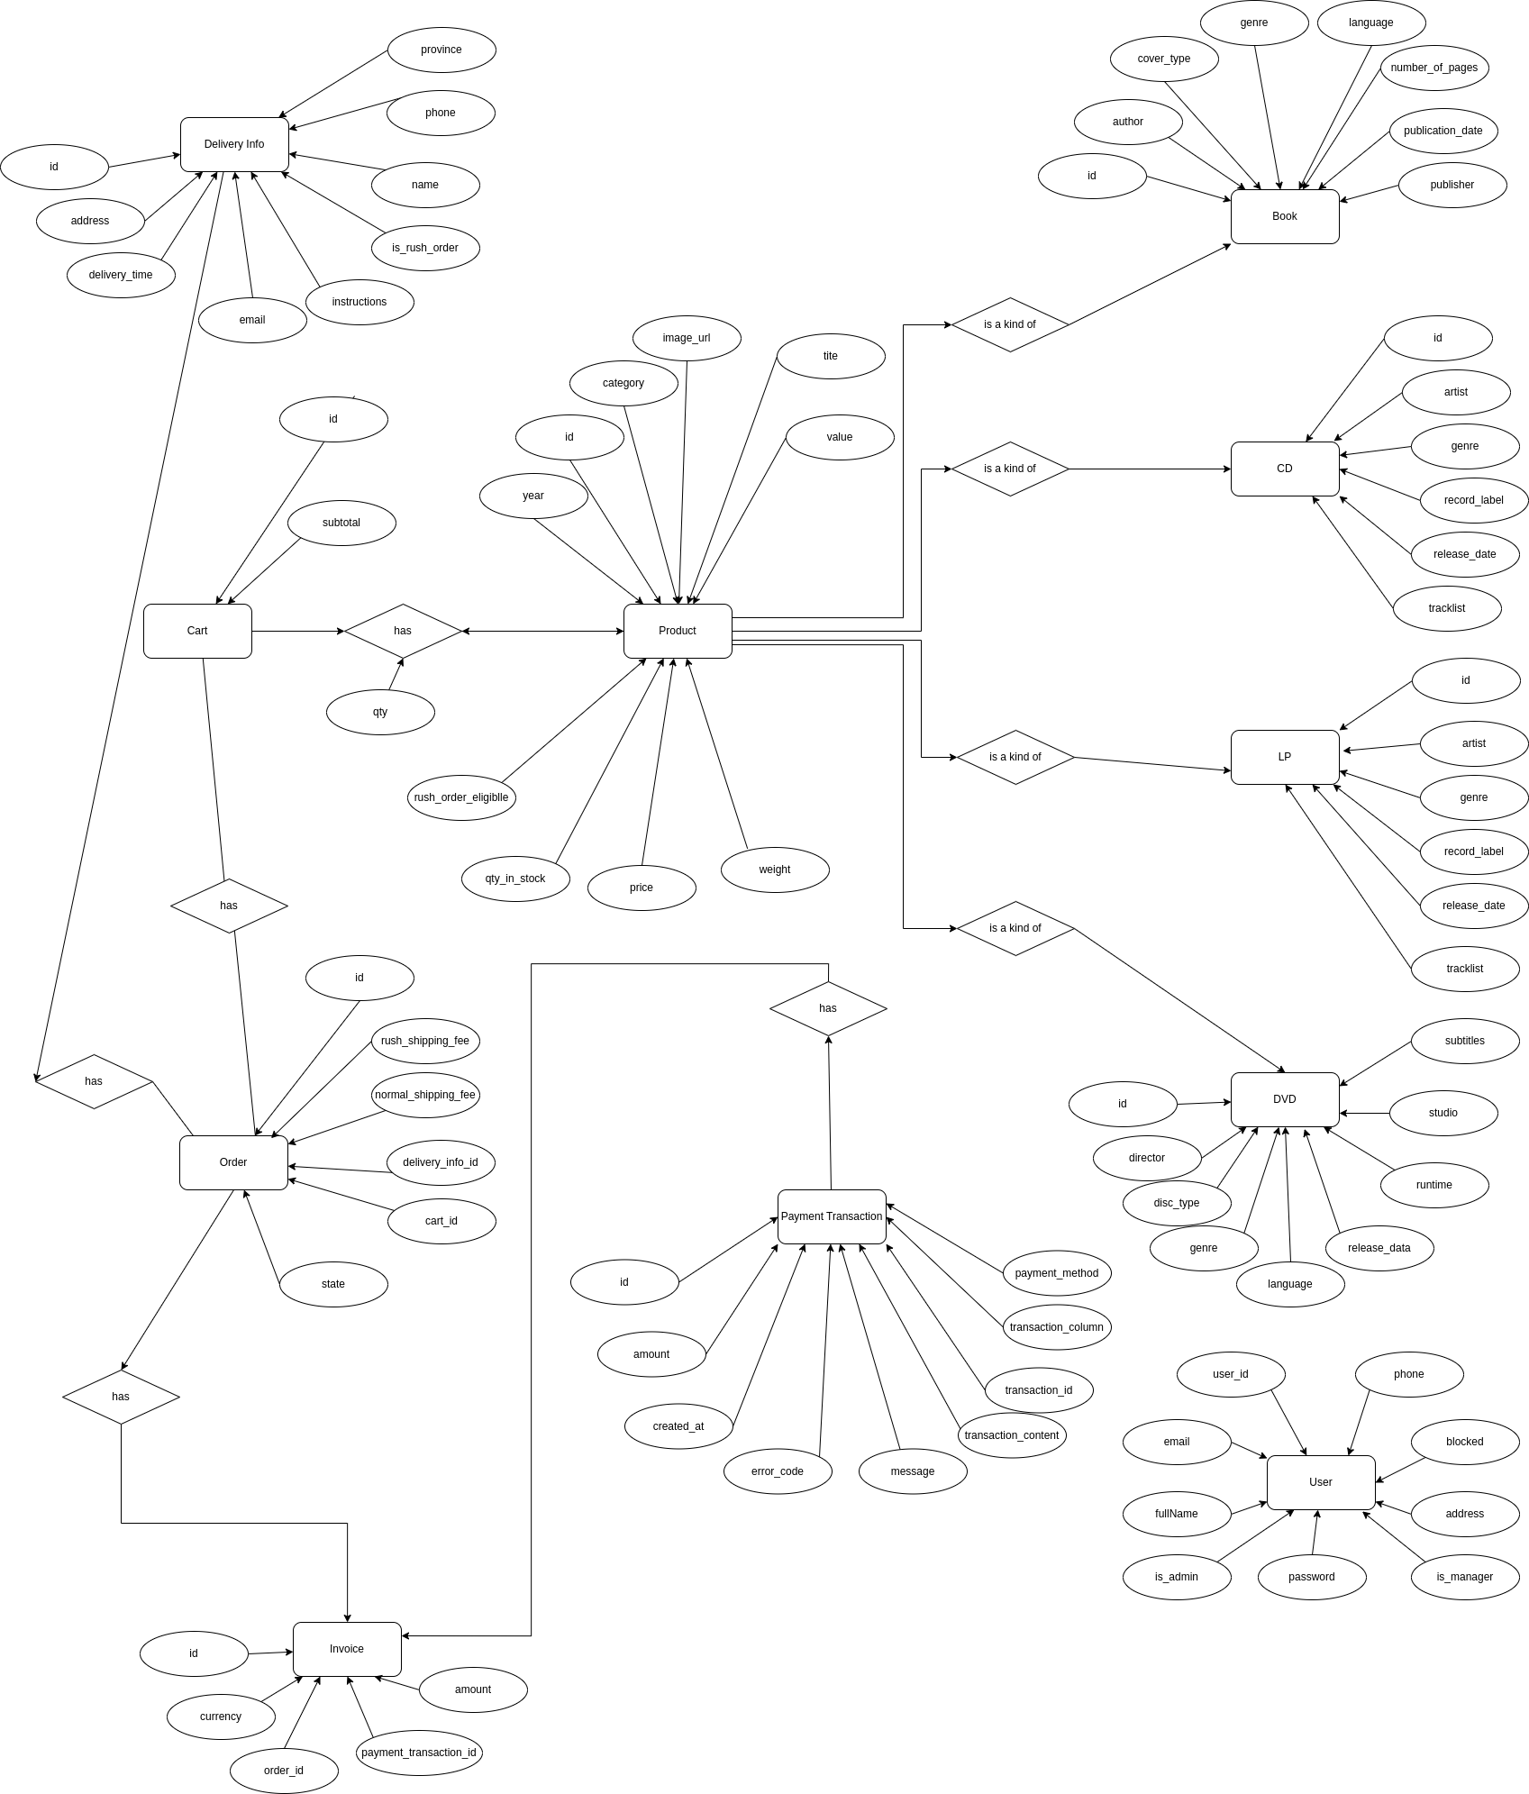

### Database Design

#### Database Management System

To manage the application's information, the system uses MySQL as the database management system. MySQL is an open-source relational database management system (RDBMS) operating on a client-server model. MySQL, integrated with Apache and PHP for RDBMS, provides powerful features such as support for various data types, data security, query optimization, user management, data backup and recovery, and scalability and customization.

In Capstone, MySQL is used to store information such as: products, users, orders, ..., their attributes, and schedules. With MySQL, the application can efficiently and securely search, add, modify, and delete information in the database. Additionally, MySQL's security features help ensure the protection of user data.

#### Database Diagram

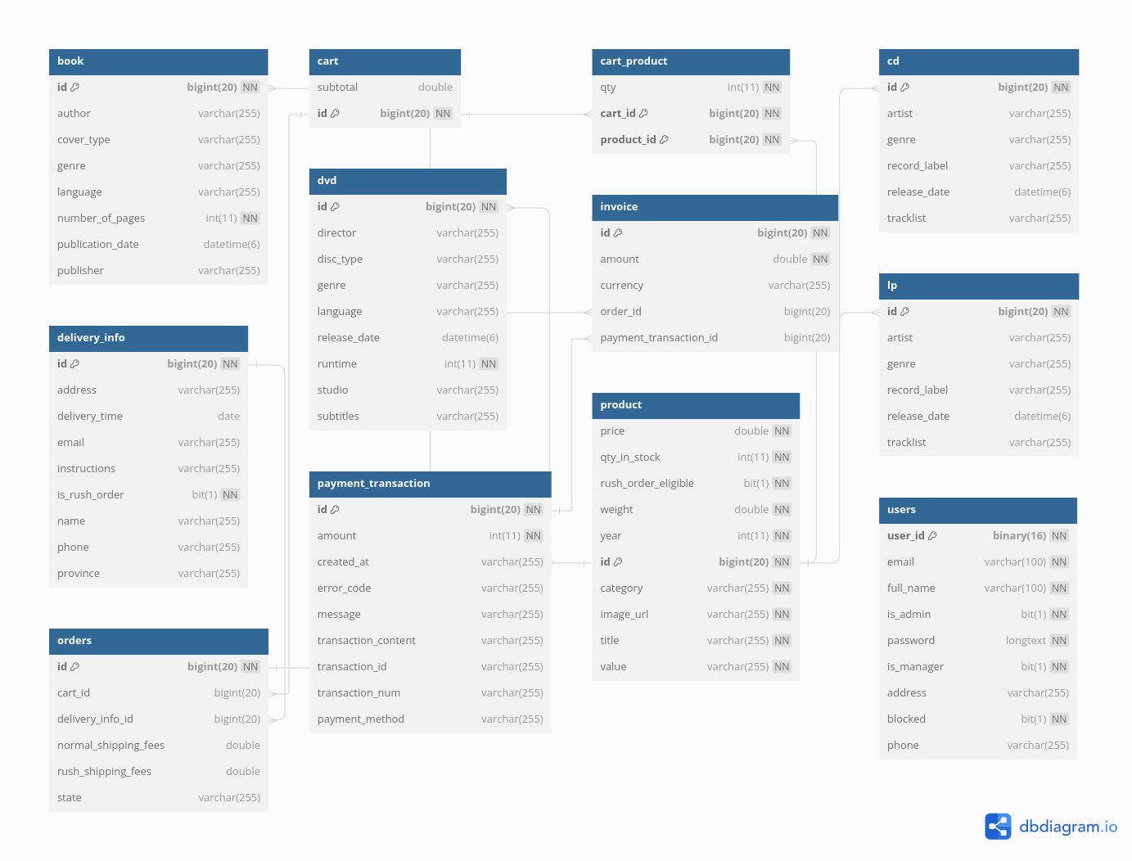

#### Database Detail Design

**- *Book***

|  |  |  |  |  |  |  |  |
| --- | --- | --- | --- | --- | --- | --- | --- |
| *#* | *PK* | *FK* | *Column name* | *Data type* | *Default value* | *Mandatory* | *Description* |
| 1 | x |  | id | Bigint(20 |  | Yes | ID, not null |
| 2 |  |  | author | Varchar(255) |  |  | Book author |
| 3 |  |  | cover_type | Varchar(255) |  |  | Book cover |
| 4 |  |  | genre | Varchar(255) |  |  | Book genre |
| 5 |  |  | language | Varchar(255) |  |  | Book language |
| 6 |  |  | Nunber of page | Int(11) |  |  | Not null |
| 7 |  |  | Publication_date | Datetime(6) |  |  |  |
| 8 |  |  | publisher | Varchar(255) |  |  |  |

* ***Cart***

|  |  |  |  |  |  |  |  |
| --- | --- | --- | --- | --- | --- | --- | --- |
| *#* | *PK* | *FK* | *Column name* | *Data type* | *Default value* | *Mandatory* | *Description* |
| 1 | x |  | id | Bigint(20 |  | Yes | ID, not null |
| 2 |  |  | subtotal | double |  | Yes | Cart subtotal |

* ***Delivery Info***

|  |  |  |  |  |  |  |  |
| --- | --- | --- | --- | --- | --- | --- | --- |
| *#* | *PK* | *FK* | *Column name* | *Data type* | *Default value* | *Mandatory* | *Description* |
| 1 | x |  | id | Bigint(20 |  | Yes | ID, not null |
| 2 |  |  | address | double |  | Yes | Address delivery |
| 3 |  |  | Delivery_time | date |  | Yes |  |
| 4 |  |  | email | Varchar(255) |  |  |  |
| 5 |  |  | Instructions | Varchar(255) |  |  |  |
| 6 |  |  | Is_rush_order | Bit(1) |  | Yes | Not null |
| 7 |  |  | name | Varchar(255) |  |  |  |
| 8 |  |  | phone | Varchar(255) |  |  |  |
| 9 |  |  | province | Varchar(255) |  | Yes |  |

* ***Order***

|  |  |  |  |  |  |  |  |
| --- | --- | --- | --- | --- | --- | --- | --- |
| *#* | *PK* | *FK* | *Column name* | *Data type* | *Default value* | *Mandatory* | *Description* |
| 1 | x |  | id | Bigint(20) |  | Yes | ID, not null |
| 2 |  | x | Cart_id | Bigint(20) |  | Yes | Cart ID |
| 3 |  | x | Delivery_info_id | Bigint(20) |  | Yes |  |
| 4 |  |  | Normal_shipping_fee | double |  | Yes |  |
| 5 |  |  | Rush_shipping_fee | double |  | Yes |  |
| 6 |  |  | state | Varchar(255) |  | Yes |  |

* ***DVD***

|  |  |  |  |  |  |  |  |
| --- | --- | --- | --- | --- | --- | --- | --- |
| *#* | *PK* | *FK* | *Column name* | *Data type* | *Default value* | *Mandatory* | *Description* |
| 1 | x |  | id | Bigint(20 |  | Yes | ID, not null |
| 2 |  |  | director | Varchar(255) |  |  |  |
| 3 |  |  | Disc_type | Varchar(255) |  |  |  |
| 4 |  |  | genre | Varchar(255) |  |  |  |
| 5 |  |  | language | Varchar(255) |  |  |  |
| 6 |  |  | Release_date | Datetime(6) |  |  |  |
| 7 |  |  | runtime | Int(11) |  |  | Not null |
| 8 |  |  | studio | Varchar(255) |  |  |  |
| 9 |  |  | subtitles | Varchar(255) |  |  |  |

* ***Payment Transaction***

|  |  |  |  |  |  |  |  |
| --- | --- | --- | --- | --- | --- | --- | --- |
| *#* | *PK* | *FK* | *Column name* | *Data type* | *Default value* | *Mandatory* | *Description* |
| 1 | x |  | id | Bigint(20 |  | Yes | ID, not null |
| 2 |  |  | amount | Int(11) |  | Yes | Not null |
| 3 |  |  | Created_at | Varchar(255) |  |  |  |
| 4 |  |  | Error_code | Varchar(255) |  | Yes |  |
| 5 |  |  | Message | Varchar(255) |  |  |  |
| 6 |  |  | Transaction_content | Varchar(255) |  |  |  |
| 7 |  | x | Transaction_id | Varchar(255) |  | Yes |  |
| 8 |  |  | Transaction_num | Varchar(255) |  | Yes |  |
| 9 |  |  | Payment_method | Varchar(255) |  | Yes |  |

* ***Cart Product***

|  |  |  |  |  |  |  |  |
| --- | --- | --- | --- | --- | --- | --- | --- |
| *#* | *PK* | *FK* | *Column name* | *Data type* | *Default value* | *Mandatory* | *Description* |
| 1 | x |  | id | Int(11) |  | Yes | ID, not null |
| 2 |  | x | Cart_id | Bigint(20) |  | Yes | Not null |
| 3 |  | x | Product_id | Bigint(20) |  | Yes | Not null |

* ***Invoice***

|  |  |  |  |  |  |  |  |
| --- | --- | --- | --- | --- | --- | --- | --- |
| *#* | *PK* | *FK* | *Column name* | *Data type* | *Default value* | *Mandatory* | *Description* |
| 1 | x |  | id | Bigint(20) |  | Yes | ID, not null |
| 2 |  |  | amount | double |  | Yes |  |
| 3 |  |  | currency | Varchar(255) |  | Yes |  |
| 4 |  | x | Order_id | Bigint(20) |  | Yes |  |
| 5 |  | x | Payment_transaction_id | Bigint(20) |  | Yes |  |

* ***Product***

|  |  |  |  |  |  |  |  |
| --- | --- | --- | --- | --- | --- | --- | --- |
| *#* | *PK* | *FK* | *Column name* | *Data type* | *Default value* | *Mandatory* | *Description* |
| 1 | x |  | id | Bigint(20) |  | Yes | ID, not null |
| 2 |  |  | price | double |  | Yes | Not null |
| 3 |  |  | Qty_in_stock | Int(11) |  | Yes | Not null |
| 4 |  |  | Rush_order_eligible | Bit(1) |  | Yes | Not null |
| 5 |  |  | weight | double |  | Yes | Not null |
| 6 |  |  | Year | Int(11) |  |  | Not null |
| 8 |  |  | Image_url | Varchar(255) |  |  | Not null |
| 9 |  |  | title | Varchar(255) |  |  | Not null |
| 10 |  |  | value | Varchar(255) |  | Yes | Not null |

* ***CD***

|  |  |  |  |  |  |  |  |
| --- | --- | --- | --- | --- | --- | --- | --- |
| *#* | *PK* | *FK* | *Column name* | *Data type* | *Default value* | *Mandatory* | *Description* |
| 1 | x |  | id | Bigint(20 |  | Yes | ID, not null |
| 2 |  |  | artist | Varchar(255) |  |  |  |
| 3 |  |  | genre | Varchar(255) |  |  |  |
| 4 |  |  | Record_label | Varchar(255) |  |  |  |
| 5 |  |  | Record_date | Datetime(6) |  |  |  |
| 6 |  |  | tracklist | Varchar(255 |  |  |  |

* ***LP***

|  |  |  |  |  |  |  |  |
| --- | --- | --- | --- | --- | --- | --- | --- |
| *#* | *PK* | *FK* | *Column name* | *Data type* | *Default value* | *Mandatory* | *Description* |
| 1 | x |  | id | Bigint(20 |  | Yes | ID, not null |
| 2 |  |  | artist | Varchar(255) |  |  |  |
| 3 |  |  | genre | Varchar(255) |  |  |  |
| 4 |  |  | Record_label | Varchar(255) |  |  |  |
| 5 |  |  | Release_date | Datetime(6) |  |  |  |
| 6 |  |  | tracklist | Varchar(255) |  |  |  |

* ***User***

|  |  |  |  |  |  |  |  |
| --- | --- | --- | --- | --- | --- | --- | --- |
| *#* | *PK* | *FK* | *Column name* | *Data type* | *Default value* | *Mandatory* | *Description* |
| 1 | x |  | id | Bigint(20 |  | Yes | ID, not null |
| 2 |  |  | email | Varchar(100) |  | Yes | Not null |
| 3 |  |  | Full_name | Varchar(100) |  | Yes | Not null |
| 4 |  |  | Is_admin | Bit(1) |  | Yes | Not null |
| 5 |  |  | password | Longtext |  | Yes | Not null |
| 6 |  |  | Is_manager | Bit(1) |  | Yes | Not null |
| 7 |  |  | address | Varchar(255) |  |  | Not null |
| 8 |  |  | blocked | Bit(1) |  | Yes | Not null |
| 9 |  |  | phone | Varchar(255) |  |  | Not null |

*Database script is available at folder backend/database/aims.sql*

## Non-Database Management System Files

NEXT_PUBLIC_API_URL=http://localhost:8080/customer

BACK_END_URL=http://localhost:8080

NEXTAUTH_SECRET=nextauth_key

### Configuration File

#### Description and Usage:

* **Purpose**: Stores application configuration settings.
* **Usage**: Both input and output.
* **Modules**:
  + **Writes**: Configuration management module.
  + **Reads**: Initialization and runtime modules.

#### File Structure:

* **Record Length**: Variable length.
* **Access Method**: Random access.
* **File Size**: Approximately 100KB.
* **Update Frequency**: Changes are infrequent, typically during application updates or maintenance.
* **Backup and Recovery**: Backup during application updates and maintenance.

## Class Design

### General Class Diagram

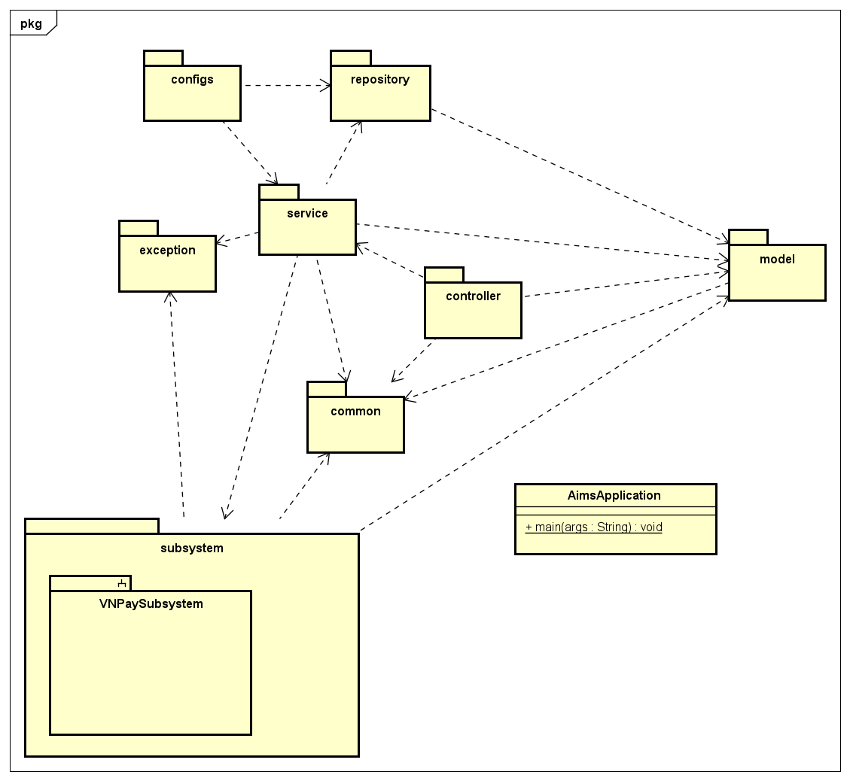

### Class Diagrams

#### Class Diagram for Package common

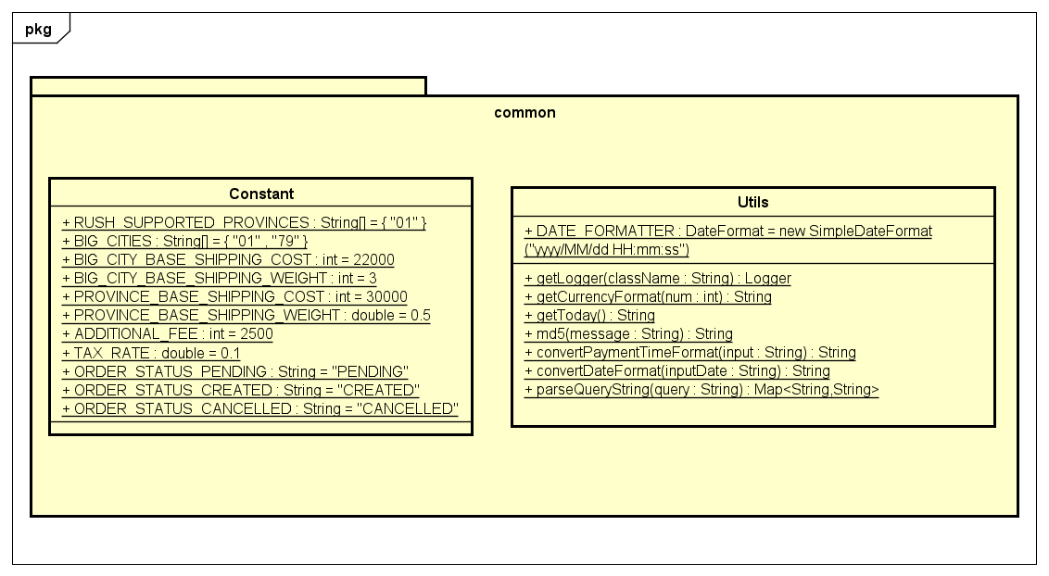

#### Class Diagram for Package configs

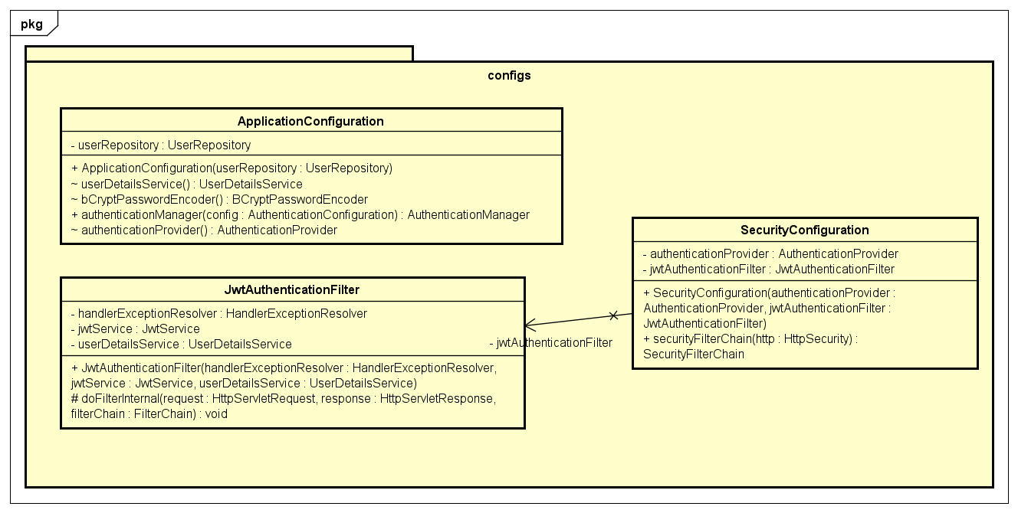

#### Class Diagram for Package controller

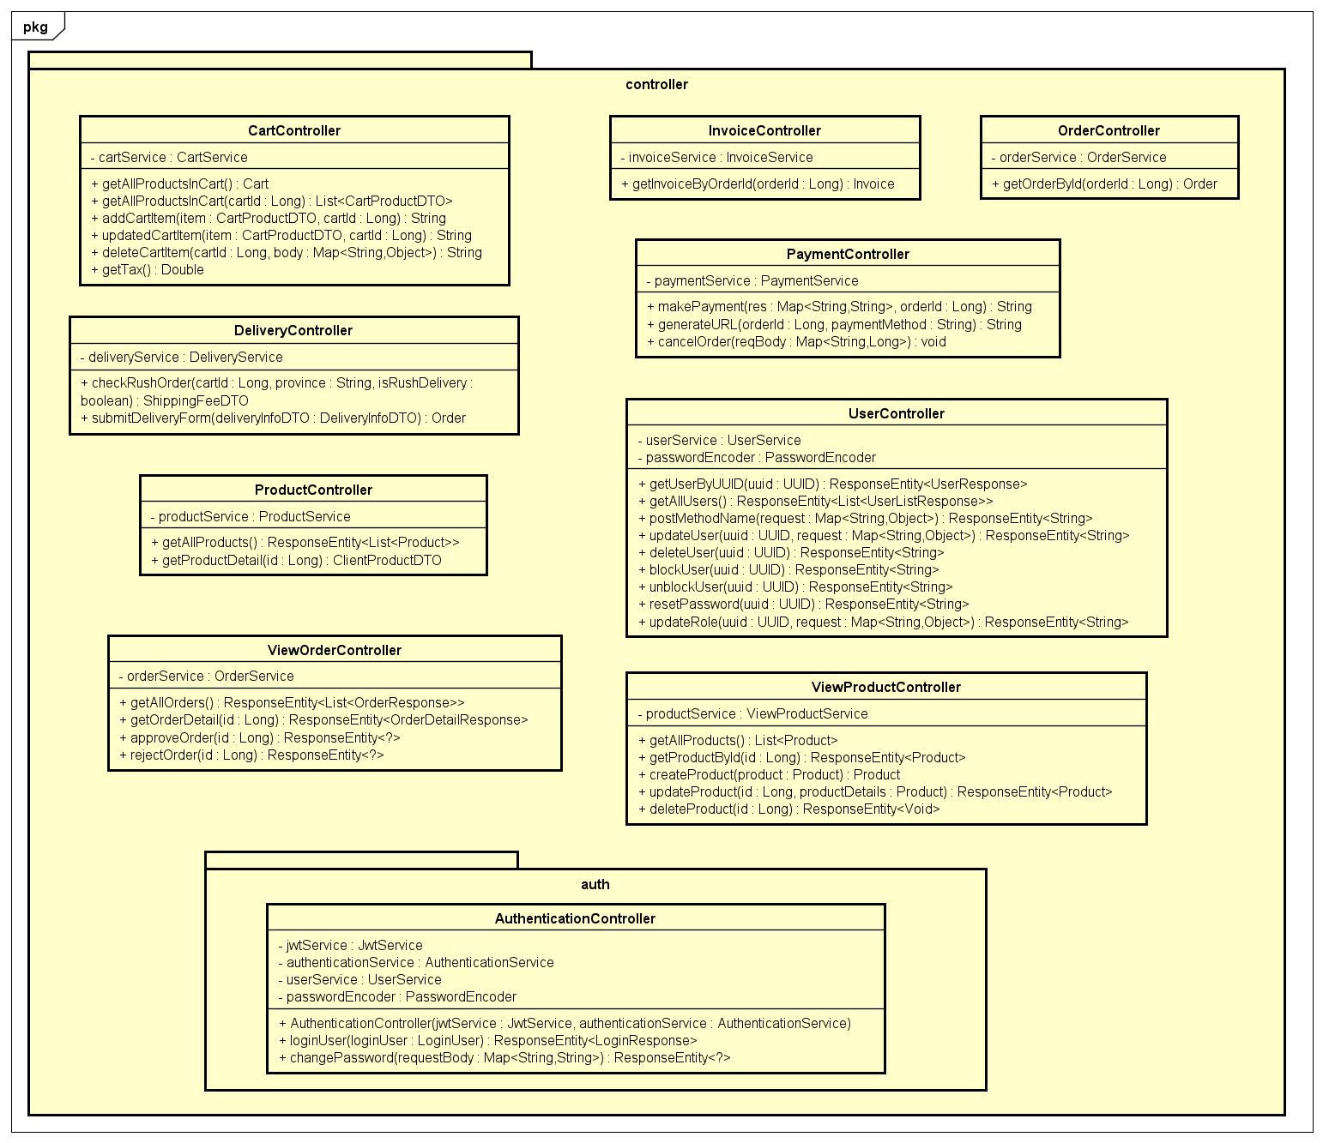

#### Class Diagram for Package model

**Subpackage dto**

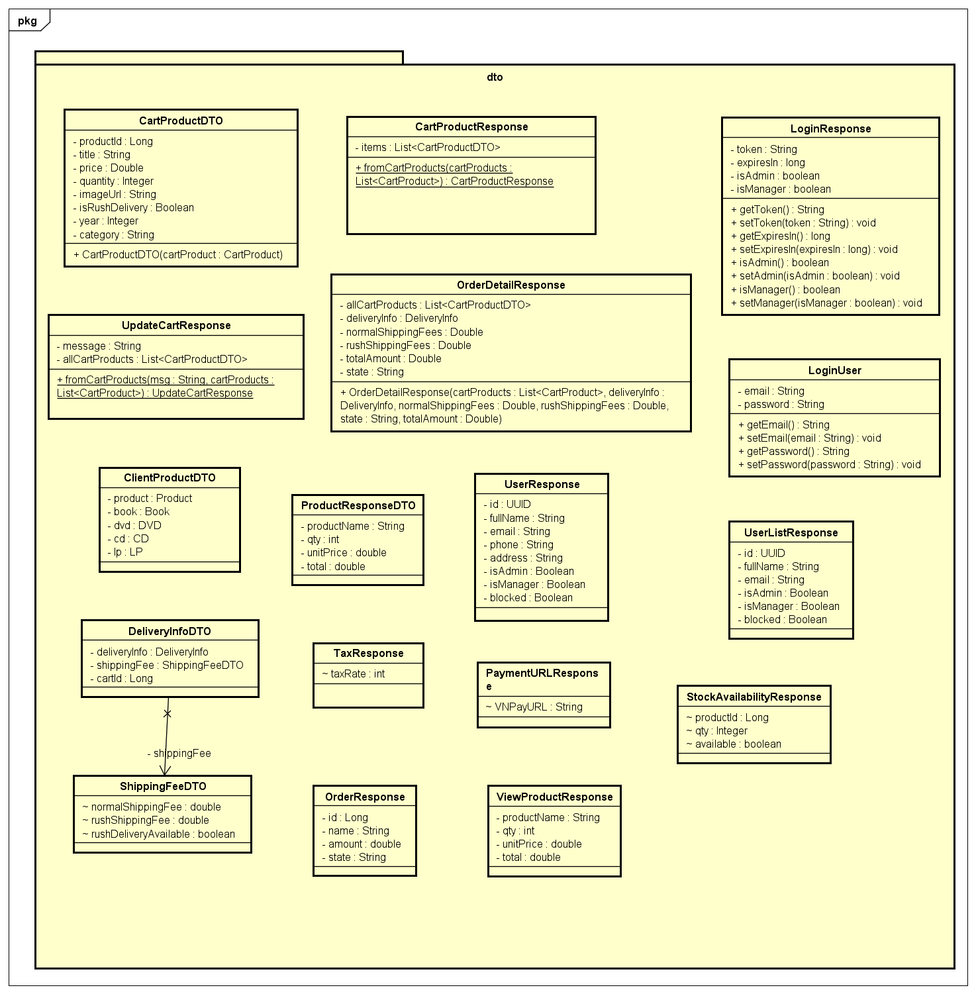

**Subpackage entity**

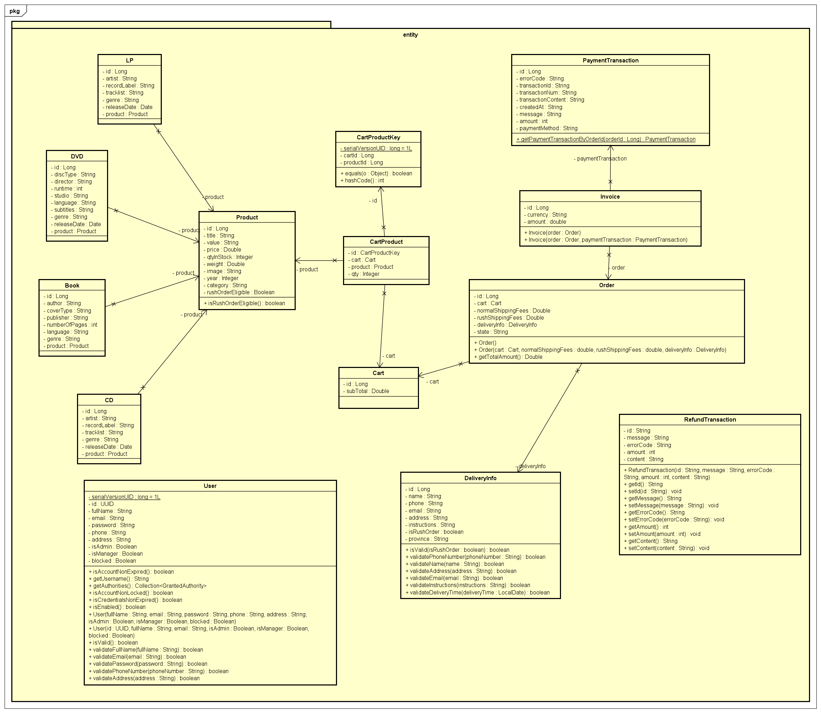

#### Class Diagram for Package exception

**Subpackage cart**

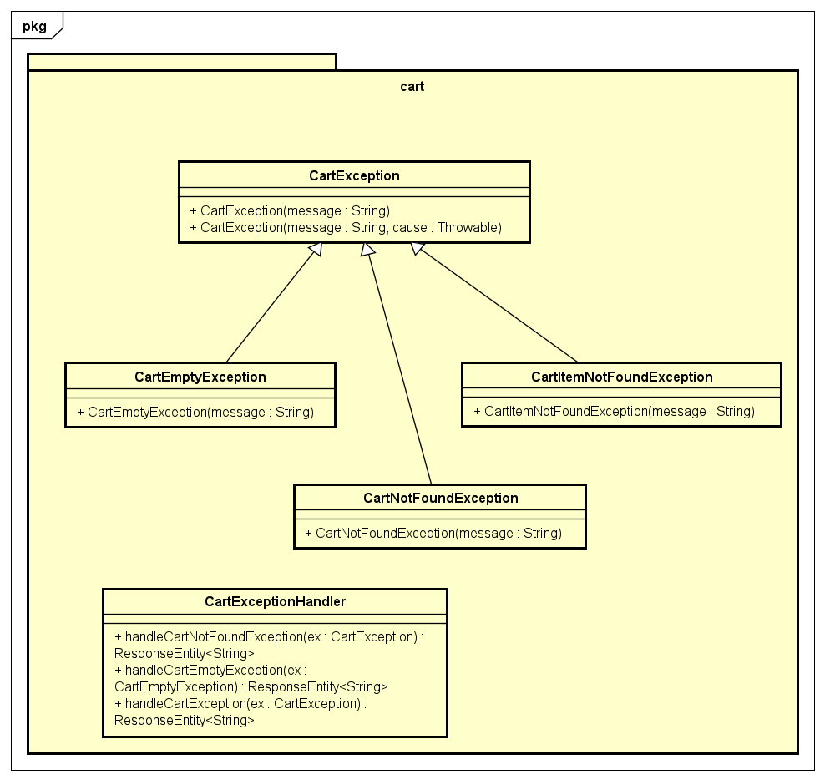

**Subpackage order**

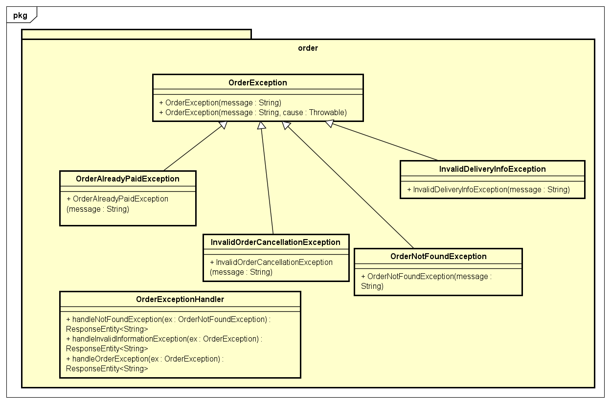

**Subpackage payment**

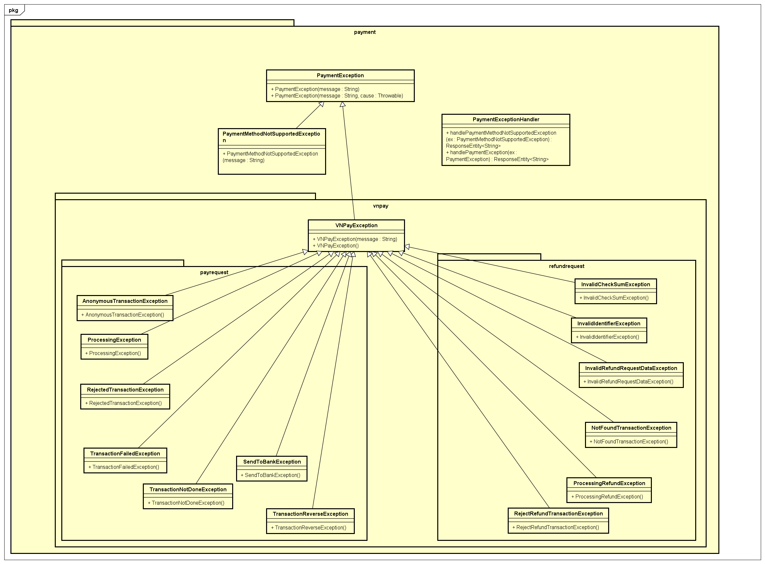

**Subpackage product**

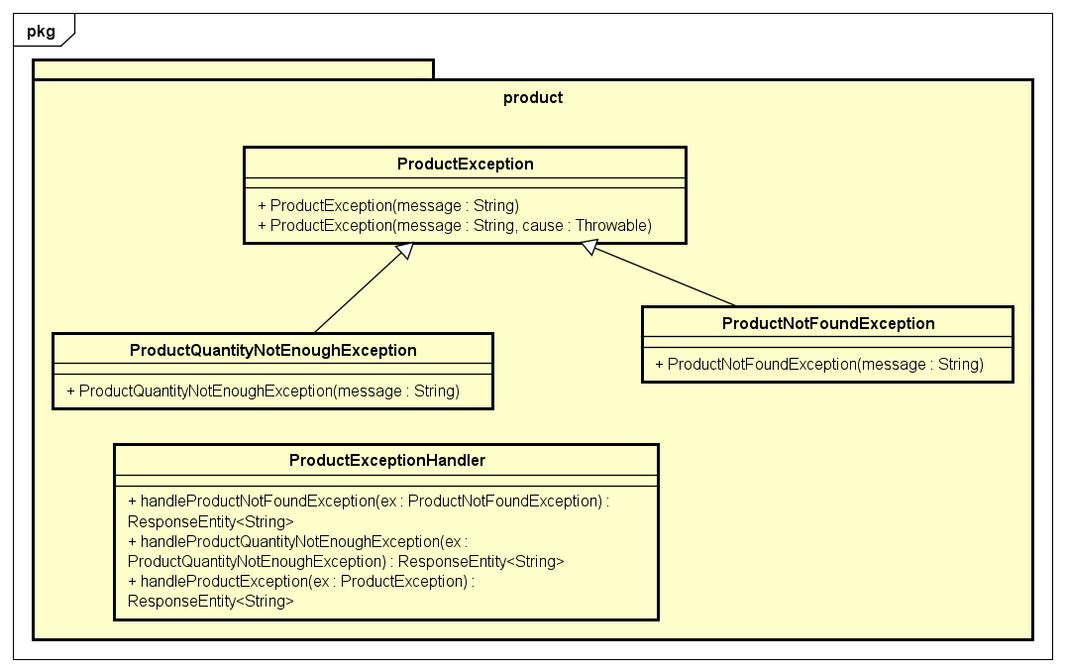

#### Class Diagram for Package repository

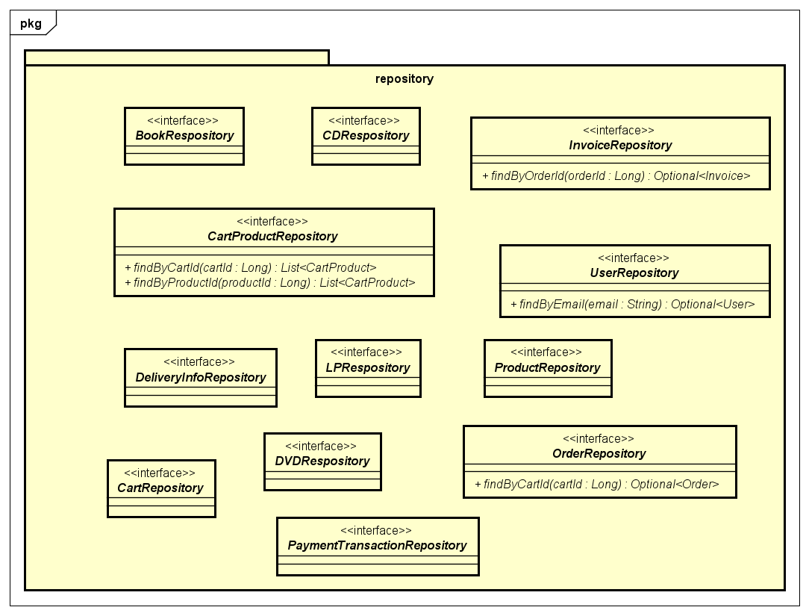

#### Class Diagram for Package service

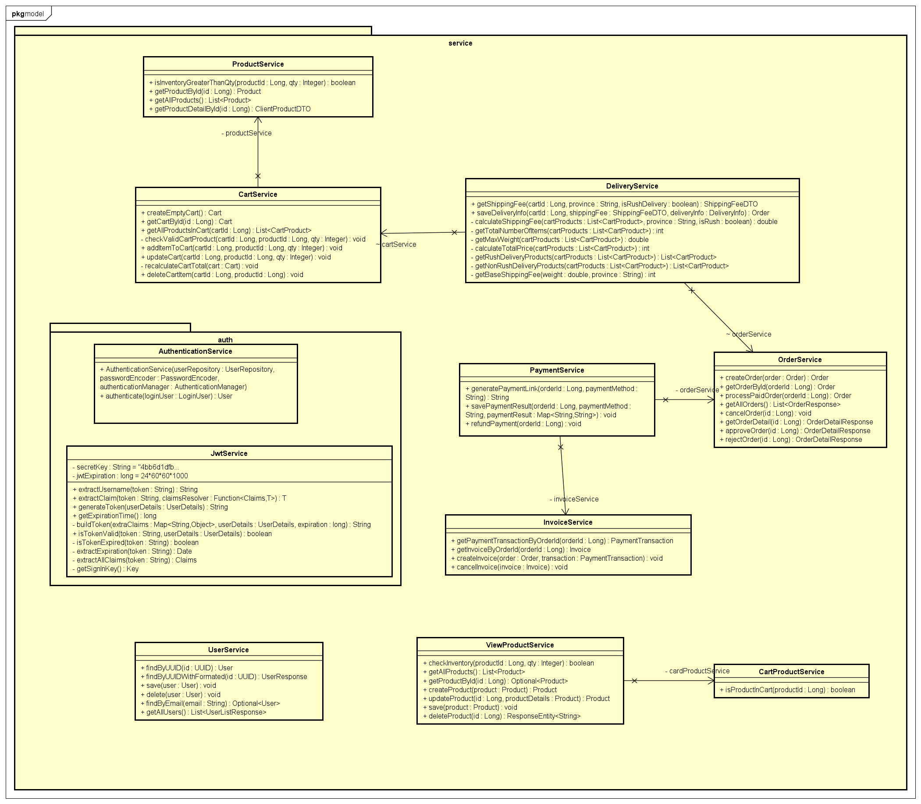

#### Class Diagram for Package subsystem

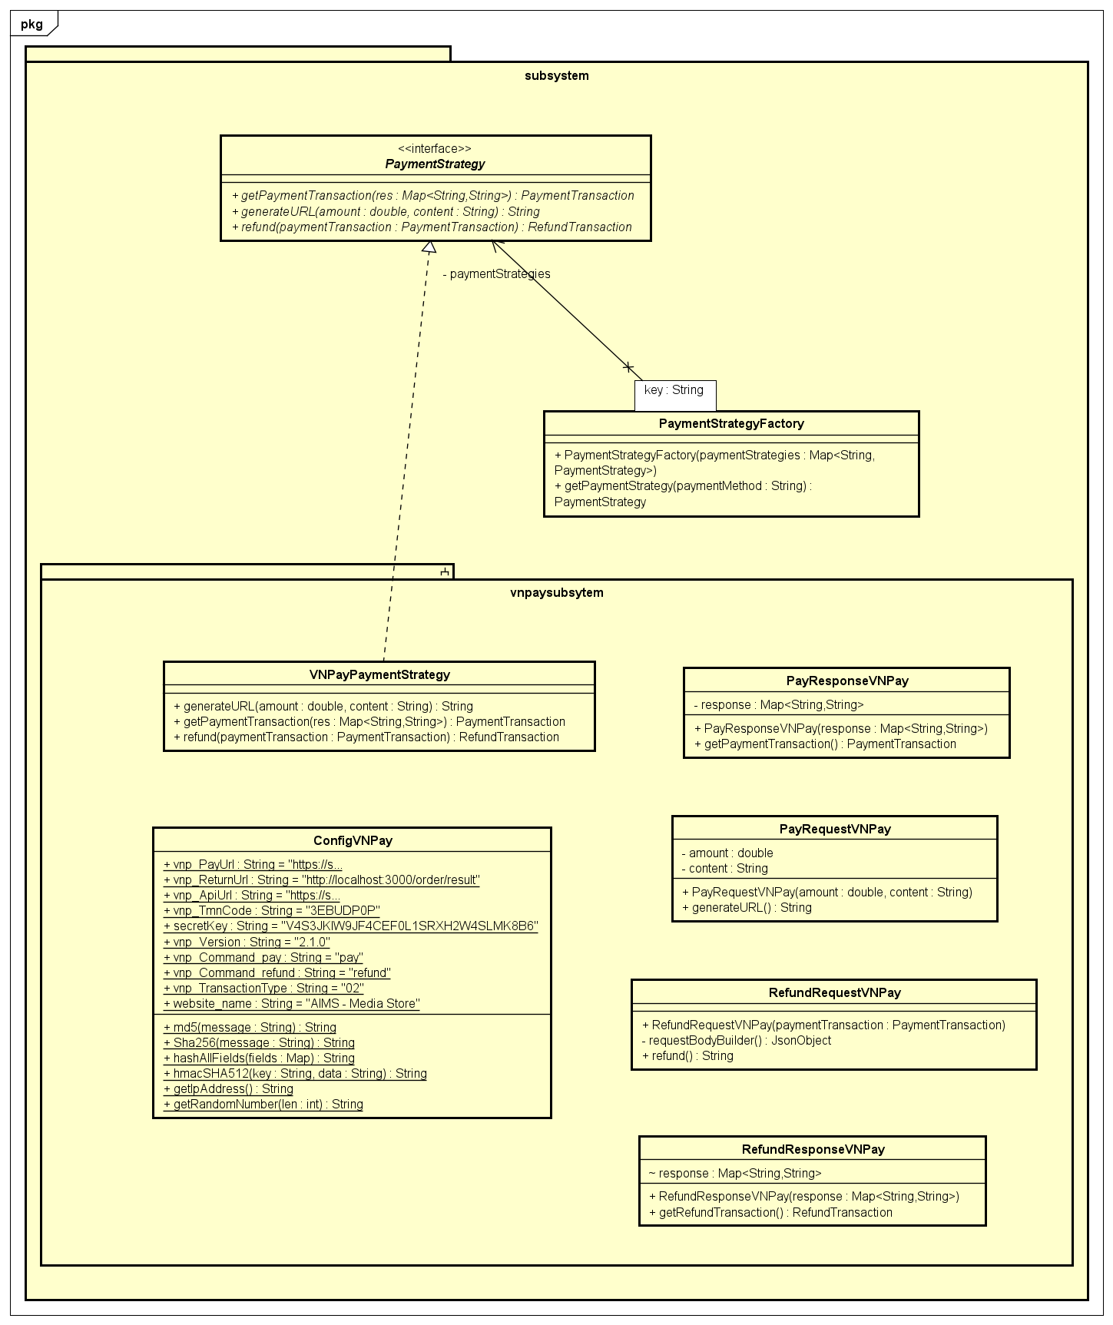

### Class Design

#### Class “OrderService”

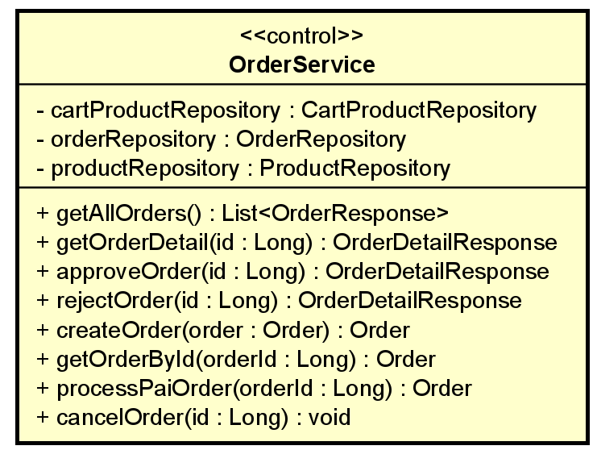

**Table 1. Attribute design for OrderService**

|  |  |  |  |  |
| --- | --- | --- | --- | --- |
| *#* | *Name* | *Data type* | *Default value* | *Description* |
| 1 | cartProductRepository | CartProductRepository |  | Interact with CartProduct entities in the database |
| 2 | orderRepository | OrderRepository |  | Interact with Order entities in the database |
| 3 | productRepository | ProductRepository |  | Interact with Product entities in the database |

**Table 2. Operation design for OrderService**

|  |  |  |  |
| --- | --- | --- | --- |
| *#* | *Name* | *Return type* | *Description (purpose)* |
| 1 | getAllOrders() | List<OrderResponse> | Retrieves all orders and converts them to a list of OrderResponse objects |
| 2 | getOrderDetail(Long id) | OrderDetailResponse | Fetches detailed information about a specific order by its ID |
| 3 | approveOrder(Long id) | OrderDetailResponse | Approves a pending order after verifying stock availability for each product in the order |
| 4 | rejectOrder(Long id) | OrderDetailResponse | Rejects a pending order |
| 5 | createOrder(Order order) | Order | Creates a new order. If an order already exists for the given cart, it deletes the existing order before saving the new one |
| 6 | getOrderById(Long orderId) | Order | Retrieves an order by its ID |
| 7 | processPaidOrder(Long orderId) | Order | Processes a paid order by changing its state to "PENDING" |
| 8 | cancelOrder(Long id) | void | Cancels an order if it is in the "PENDING" state |

*Parameter*:

* id, orderId : Long a code that uniquely identifies an order
* order : Order the order to be created

*Exception*:

* **getOrderDetail(Long id)** throws Exception if the order with the specified ID is not found
* **approveOrder(Long id)** throws Exception if the order with the specified ID or the corresponding product in the order is not found. Also throws IllegalStateException if the order is not in a pending state or if any product in the order does not have sufficient stock
* **rejectOrder(Long id)** throws Exception if the order with the specified ID is not found. Also throws IllegalStateException if the order is not in a pending state
* **getOrderById(Long orderId)** throws OrderNotFoundException if the order with the given ID is not found
* **cancelOrder(Long id)** throws InvalidOrderCancellationException if the order is not in the "PENDING" state

#### Class “UserService”

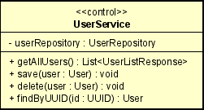

**Table 1. Attribute design for UserService**

|  |  |  |  |  |
| --- | --- | --- | --- | --- |
| *#* | *Name* | *Data type* | *Default value* | *Description* |
| 1 | userRepository | UserRepository |  | Interact with User entities in the database |

**Table 2. Operation design for UserService**

|  |  |  |  |
| --- | --- | --- | --- |
| *#* | *Name* | *Return type* | *Description (purpose)* |
| 1 | getAllUsers () | List<UserListResponse> | Retrieves all users and converts them to a list of UserListResponse objects |
| 2 | save (User user) | User | Save user information to database |
| 3 | delete (User user) | void | Delete user in database |
| 4 | findByUUID (UUID: id) | User | Find user by UUID and return user information. |

*Parameter*:

* id: Long a code that uniquely identifies an order
* user: User object.

*Exception*:

* **findByUUID (UUID: id)** throws Exception if the order with the specified ID is not found

#### Class “ProductService”

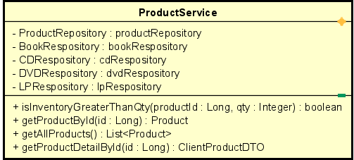

**Table 1. Attribute design for ProductService**

|  |  |  |  |  |
| --- | --- | --- | --- | --- |
| *#* | *Name* | *Data type* | *Default value* | *Description* |
| 1 | productReposirory | ProductReposirory |  | Interacts with Product entities in the database |
| 2 | bookReposirory | BookReposirory |  | Interacts with Book entities in the database |
| 3 | cdReposirory | CDReposirory |  | Interacts with CD entities in the database |
| 4 | dvdReposirory | DVDReposirory |  | Interacts with DVD entities in the database |
| 5 | lpReposirory | LPReposirory |  | Interacts with LP (vinyl record) entities in the database |

**Table 2. Operation design for Product Service**

|  |  |  |  |
| --- | --- | --- | --- |
| *#* | *Name* | *Return type* | *Description (purpose)* |
| 1 | getAllProduct () | List<Product> | This method retrieves a list of all products available in the inventory. It fetches basic information about each product, such as the product name, price, and category |
| 2 | getProductDetailById() | Long id | This method retrieves detailed information about a specific product identified by its unique ID. It includes data such as the product description, specifications, pricing, and availability. |
| 3 | getProductById | Product | This method retrieves detailed information about a specific product identified by its unique ID |
| 4 | isInventoryGreaterThaQty | Boolean | This method check if Inventory is greater than qunatity. |

*Parameter Descriptions:*

* **productId:** Long - A unique identifier for a product.
* **qty:** Integer - The quantity to compare against the product's inventory.
* **id:** Long - A unique identifier for a product.

*Exception Handling:*

* **getProductById(Long id):** Throws ProductNotFoundException if the product with the specified ID is not found.
* **getProductDetailById(Long id):** Throws ProductNotFoundException if the product with the specified ID is not found.

#### Class “DeliveryService”

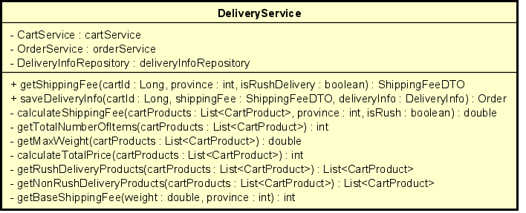

**Table 1. Attribute design for DeliveryService**

|  |  |  |  |  |
| --- | --- | --- | --- | --- |
| *#* | *Name* | *Data type* | *Default value* | *Description* |
| 1 | cartService | CartService |  | Interacts with Cart entities and manages cart-related operations |
| 2 | orderService | OrderService |  | Manages order-related operations |
| 3 | deliveryInfoRepository | DeliveryInfoRepository |  | Interacts with DeliveryInfo entities in the database |

**Table 2. Operation design for Delivery Service**

|  |  |  |  |
| --- | --- | --- | --- |
| *#* | *Name* | *Return type* | *Description (purpose)* |
| 1 | getShippingfee(Long cartId, int province, boolean isRushDelivery) | ShippingFeeDTO | Calculates the shipping fee based on the cart contents, delivery province, and rush delivery option. |
| 2 | saveDeliveryInfo(Long cartId, ShippingFeeDTO shippingFee, DeliveryInfo deliveryInfo) | Order | Saves delivery information and creates an order. Throws InvalidDeliveryInfoException if delivery info is invalid. |

*Parameter Descriptions:*

* **cartId:** Long - A unique identifier for the cart.
* **province:** int - The delivery province.
* **isRushDelivery:** boolean - Indicates if rush delivery is requested.
* **shippingFee:** ShippingFeeDTO - Shipping fee details.
* **deliveryInfo:** DeliveryInfo - Delivery information entity.

*Exception Handling:*

* **saveDeliveryInfo(Long cartId, ShippingFeeDTO shippingFee, DeliveryInfo deliveryInfo):** Throws InvalidDeliveryInfoException if the delivery information is invalid.

#### Class “CartService”

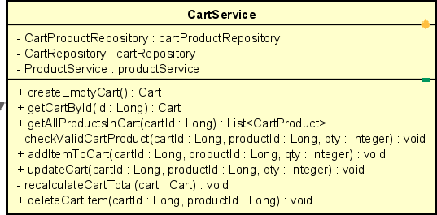

**Table 1. Attribute design for CartService**

|  |  |  |  |  |
| --- | --- | --- | --- | --- |
| *#* | *Name* | *Data type* | *Default value* | *Description* |
| 1 | cartProductRepository | CartProductRepository |  | Interacts with CartProduct entities in the database |
| 2 | cartRepository | CartRepository |  | Interacts with Cart entities in the database |
| 3 | productService | ProductService |  | Interacts with Product entities and manages product-related operations |

**Table 2. Operation design for CartService**

|  |  |  |  |
| --- | --- | --- | --- |
| *#* | *Name* | *Return type* | *Description (purpose)* |
| 1 | createEmptyCart() | Cart | Creates and saves a new empty cart, then returns the cart. |
| 2 | getCartById(Long id) | Cart | Retrieves the cart with the specified ID. Throws CartNotFoundException if the cart is not found. |
| 3 | getAllProductsInCart(Long cartId) | List<CartProduct> | Retrieves all products in the specified cart. Throws CartNotFoundException if the cart is not found. |
| 4 | addItemToCart(Long cartId, Long productId, Integer qty) | void | Adds a specified quantity of a product to the cart. Updates the cart if the product already exists. Throws ProductQuantityNotEnoughException if there is not enough product in stock. |
| 5 | updateCart(Long cartId, Long productId, Integer qty) | void | Updates the quantity of a specified product in the cart. Throws ProductQuantityNotEnoughException if there is not enough product in stock. |
| 6 | deleteCartItem(Long cartId, Long productId) | void | Deletes a specified product from the cart. Throws CartItemNotFoundException if the product is not found in the cart. |

*Parameter Descriptions:*

* **id:** Long - A unique identifier for the cart.
* **cartId:** Long - A unique identifier for the cart.
* **productId:** Long - A unique identifier for the product.
* **qty:** Integer - The quantity of the product to be added or updated in the cart.

Exception Handling:

* **getCartById(Long id):** Throws CartNotFoundException if the cart with the specified ID is not found.
* **addItemToCart(Long cartId, Long productId, Integer qty):** Throws ProductQuantityNotEnoughException if there is not enough product in stock.
* **updateCart(Long cartId, Long productId, Integer qty):** Throws ProductQuantityNotEnoughException if there is not enough product in stock.
* **deleteCartItem(Long cartId, Long productId):** Throws CartItemNotFoundException if the product is not found in the cart.

#### Class “PaymentService”

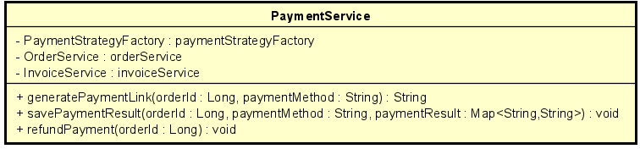

**Table 1. Attribute design for PaymentService**

|  |  |  |  |
| --- | --- | --- | --- |
| *#* | *Name* | *Return type* | *Description (purpose)* |
| 1 | paymentStrategyFactory | PaymentStrategyFactory | Factory to get appropriate payment strategy based on payment method |
| 2 | orderService | OrderService | Interacts with Order entities and manages order-related operations |
| 3 | invoiceService | InvoiceService | Manages invoice-related operations and interactions with payment transactions |

**Table 2. Operation design for PaymentService**

|  |  |  |  |
| --- | --- | --- | --- |
| *#* | *Name* | *Return type* | *Description (purpose)* |
| 1 | generatePaymentLink(Long orderId, String paymentMethod) | String | Generates and returns a payment link for the specified order using the specified payment method. Throws OrderAlreadyPaidException if the order is already paid. |
| 2 | getCartById(Long id) | Cart | Retrieves the cart with the specified ID. Throws CartNotFoundException if the cart is not found. |
| 3 | savePaymentResult(Long orderId, String paymentMethod, Map<String, String> paymentResult) | void | Saves the payment result for the specified order using the specified payment method. Throws OrderAlreadyPaidException if the order is already paid. |
| 4 | refundPayment(Long orderId) | void | Processes a refund for the specified order. Throws InvalidOrderCancellationException if the order cannot be canceled. |

*Parameter Descriptions:*

* **orderId:** Long - A unique identifier for the order.
* **paymentMethod:** String - The method of payment used for the order.
* **paymentResult:** Map<String, String> - A map containing the payment result details.

*Exception Handling:*

* **generatePaymentLink(Long orderId, String paymentMethod):** Throws OrderAlreadyPaidException if the order with the specified ID is already paid.
* **savePaymentResult(Long orderId, String paymentMethod, Map<String, String> paymentResult):** Throws OrderAlreadyPaidException if the order with the specified ID is already paid.
* **refundPayment(Long orderId):** Throws InvalidOrderCancellationException if the order with the specified ID cannot be canceled.

#### Class “InvoiceService”

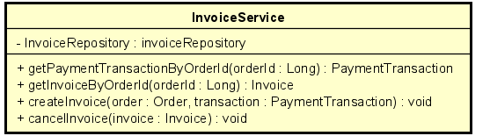

**Table 1. Attribute design for InvoiceService**

|  |  |  |  |
| --- | --- | --- | --- |
| *#* | *Name* | *Return type* | *Description (purpose)* |
| 1 | invoiceRepository | InvoiceRepository | Repository for interacting with Invoice entities in the database |

**Table 2. Operation design for InvoiceService**

|  |  |  |  |
| --- | --- | --- | --- |
| *#* | *Name* | *Return type* | *Description (purpose)* |
| 1 | getPaymentTransactionByOrderId(Long orderId) | PaymentTransaction | Retrieves the payment transaction associated with the specified order ID. Throws OrderNotFoundException if the order or invoice is not found. |
| 2 | getInvoiceByOrderId(Long orderId) | Invoice | Retrieves the invoice associated with the specified order ID. Throws OrderNotFoundException if the order or invoice is not found. |
| 3 | createInvoice(Order order, PaymentTransaction transaction) | void | Creates and saves a new invoice for the specified order and payment transaction. |
| 4 | cancelInvoice(Invoice invoice) | void | Deletes the specified invoice from the database. |

*Parameter Descriptions:*

* **orderId:** Long - A unique identifier for the order.
* **order:** Order - An Order entity to create an invoice for.
* **transaction:** PaymentTransaction - A PaymentTransaction entity associated with the order.
* **invoice:** Invoice - An Invoice entity to be canceled.

*Exception Handling:*

* **getPaymentTransactionByOrderId(Long orderId):** Throws OrderNotFoundException if the order with the specified ID or its invoice is not found.
* **getInvoiceByOrderId(Long orderId):** Throws OrderNotFoundException if the order with the specified ID or its invoice is not found.

# Design Considerations

## Architecture Strategies

We decided to develop a web application for our Media Store online system due to its accessibility for average users and the common association of web applications with e-commerce systems. Adopting a backend-frontend architecture, we chose the following tech stack:

* **Backend**: Spring Boot
* **Frontend**: Next.js
* **Database**: MySQL

### Backend Architecture: Spring Boot

Spring Boot is a Java-based backend framework designed for building microservices. We selected Spring Boot for several reasons:



* **Scalability**: The microservices architecture of Spring Boot allows for easy scaling and expansion of the project as requirements evolve. Individual services can be developed, deployed, and scaled independently.
* **Object-Oriented Programming (OOP)**: Java, being an OOP language, facilitates the application of design principles, making it easier to track the code workflow and identify poor practices. This leads to better maintainability and readability of the code.

### Frontend Architecture: Next.js

Next.js is a popular front-end framework based on React. We chose Next.js for its ability to help us build a user-friendly UI and its extensive features, including:



* **Flexibility and Extensibility**: With a wide variety of packages and plugins, Next.js makes it easy to add new features as project requirements change.
* **Developer Experience**: Next.js encourages good design principles at a high level, such as code reuse and modular architecture, making it easier for developers to integrate new features and maintain the codebase.

### Database System: MySQL

We selected MySQL as our database system for the following reasons:

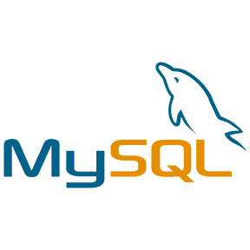

* **Reliability**: MySQL is a proven and reliable database management system, which is crucial for an e-commerce platform where data integrity and correctness are paramount.
* **Scalability**: MySQL supports horizontal and vertical scaling, providing room for future expansion and modifications to the database structure as the project grows.

## Goals and Guidelines

### User-Friendly UI Design

* **Ease of Use**: The user interface should be intuitive, enabling users to complete tasks seamlessly. Each user interaction, from browsing products to completing a purchase, should be straightforward and guided by clear prompts and instructions.
* **Error Handling**: Should an error occur, users should receive immediate, clear notifications. Error messages should explain the issue and suggest corrective actions, helping users resolve problems without frustration.

### Robust Backend Design

* **Request Handling**: The backend should be robust, with mechanisms to recognize and handle bad requests early. This ensures that invalid requests do not impact system performance or stability.
* **Authentication and Authorization**: Implement robust authentication and authorization mechanisms to protect user data and ensure that only authorized users can access specific resources. Utilize secure protocols and best practices, such as JWT and role-based access control (RBAC), to safeguard the system from unauthorized access.

### Reliable Database Design

* **Data Compliance**: The database should be meticulously designed to ensure data compliance with the problem statement. This includes proper schema design, data validation, and adherence to business rules.

## Coupling and Cohesion

### Coupling

The level of coupling in the project ranges from average (control coupling) to low coupling (data coupling).

Spring Boot is designed to encourage a loosely coupled architecture through the separation of concerns into distinct modules such as controllers, services, repositories, and entities. This separation aids in achieving several key metrics:

* **Error Isolation**: By decoupling different parts of the application, errors in one module are less likely to affect others.
* **Extensibility**: Loose coupling makes it easier to extend and modify the application as new requirements emerge.

Typically, the request flow in a Spring Boot application is as follows:

* **Controller Layer**: Receives the incoming request and validates the input data.
* **Service Layer**: Handles business logic. The controller delegates the business logic to this layer after validation.
* **Repository Layer**: Manages data access. Services interact with repositories to perform CRUD operations on entities.
* **Exception Handling**: Exceptions thrown in the service layer are redirected to the exception controller class using annotations like @ControllerAdvice and @ExceptionHandler.

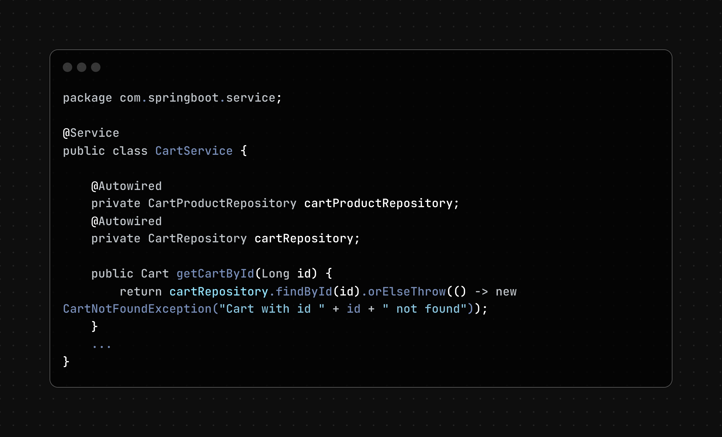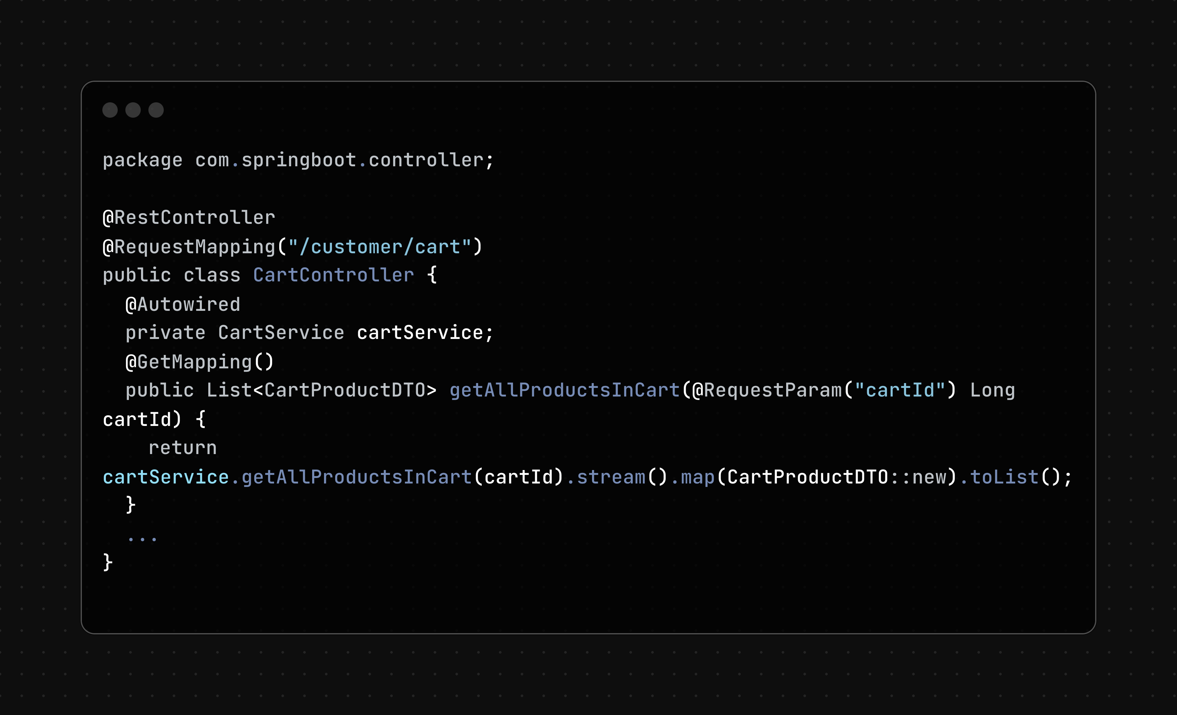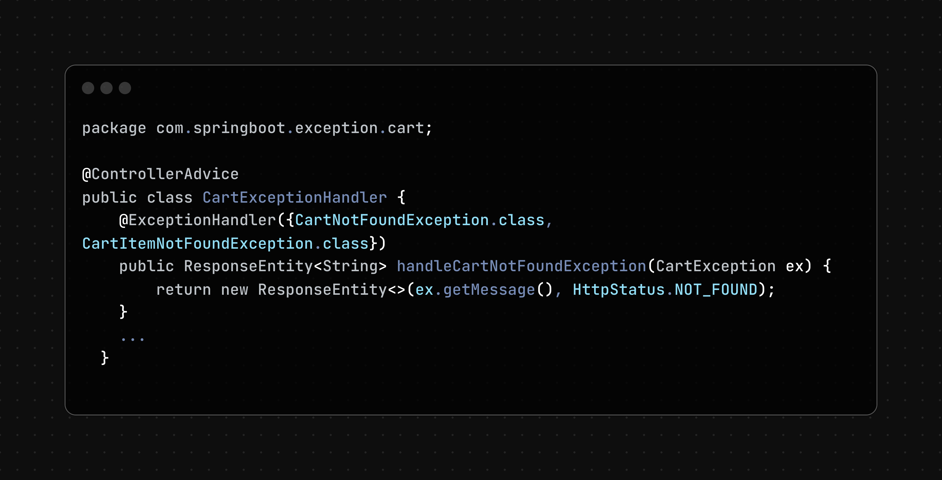

This structure supports low coupling by ensuring that:

* Controllers only handle request validation and delegate business logic to services.
* Services use repositories for data access and call other services when needed instead of directly accessing other repositories.
* Exception handling is centralized, reducing error propagation across modules.

Still, some code may not strictly follow this pattern, leading to complex coupling between modules. For example, handling business logic in the controller, as shown below, is not advisable:

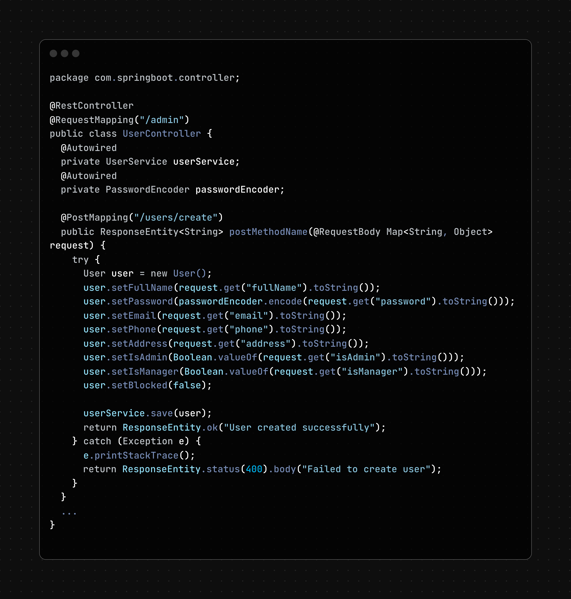

This approach leads to control coupling and stamp coupling, where the controller is tightly coupled with the entity class. Changes in the entity would necessitate changes in the controller, introducing errors and maintenance challenges.

**Recommendations**

To minimize coupling, we recommend strictly following the proposed pattern:

* **Keep Business Logic in Services**: Business logic should reside in services, with controllers focusing only on handling requests and responses.
* **Refactor Services**: Ensure services are well-structured to efficiently handle business logic and can be reused across different controllers.
* **Encapsulate Logic**: Transforming entities should be encapsulated within entities or services, keeping controllers independent of specific entity transformations.

### Cohesion

Cohesion refers to the degree of relatedness of the elements (functions, classes, or modules) within a module (such as a service) in software design. In our e-commerce project, we primarily focus on achieving Communication Cohesion and Sequential Cohesion.

Communication Cohesion:

* Functions within the service layer are organized to perform a series of actions to achieve a specific business objective.
* Functions often pipeline with each other to provide input and output, reuse code, and prevent code duplication.
* Each service function serves as an entry point for a controller and returns the result, ensuring that functions are cohesive and focused.

**Sequential Cohesion**:

* The service functions are arranged sequentially to accomplish the task at hand.
* This ensures that each function builds upon the result of the previous one, maintaining a clear and logical flow of operations.

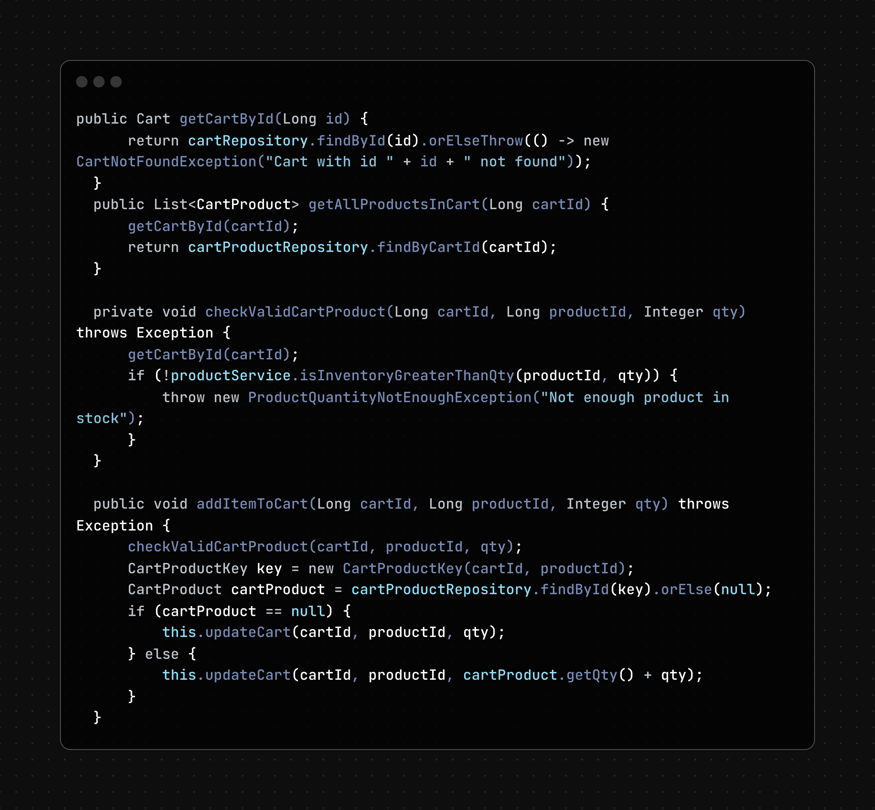

**Benefits**

* **Code Reusability**: Functions within the service layer can reuse code and avoid duplication by pipelining their operations.
* **Clear Responsibilities**: Each service function has a single responsibility and serves as an entry point for a controller, ensuring good cohesion.
* **Maintainability**: The sequential arrangement of functions and their clear communication cohesion make the codebase easier to maintain and extend.

## Design Principles

In our design, we adhere to several design principles, including SOLID principles, to ensure a well-structured and maintainable e-commerce system.

**Single Responsibility Principle (SRP)**

* **Implementation**: We divide the project into multiple packages (controllers, services, exceptions), each handling specific roles.
* **Benefits**: This approach allows us to manage classes effectively, ensuring clear responsibilities and facilitating easier maintenance and modifications.

**Open-Closed Principle (OCP)**

* **Implementation**: Classes are designed to be easily extendable without requiring modification to the existing code.
* **Example**: Adding new payment methods or modifying data storage mechanisms can be done without changing existing code extensively.
* **Limitations**: Some parts may require further modification, especially when expanding the supported range of products.

**Liskov Substitution Principle (LSP)**

* **Implementation**: Child classes can replace parent classes without affecting the system's functionality.

**Interface Segregation Principle (ISP)**

* **Implementation**: Interfaces are segregated to include only the necessary methods for specific functionalities.
* **Example**: The PaymentStrategy interface only defines methods necessary for payment transactions, ensuring lean and focused interfaces.

**Dependency Inversion Principle (DIP)**

* **Implementation**: Dependencies are abstracted, and high-level modules depend on interfaces rather than concrete implementations.
* **Implementation**: The PaymentService depends on the PaymentStrategy interface rather than concrete payment classes (VNPayStrategy).

**New Issues and Considerations**

* **New Types of Media**: When new types of media are introduced, adjustments may be needed to support these media appropriately in how they are returned to clients.
* **Changes in Delivery Calculations**: The calculation for delivery methods and pricing, especially for rush delivery in specific provinces or cities, can be easily redefined within the DeliveryService and adjusted in a configuration class.

## Design Pattern

### Strategy Pattern

The Strategy Pattern is a behavioral design pattern that defines a family of algorithms, encapsulates each one, and makes them interchangeable, allowing the algorithm to vary independently from clients that use it.

In our e-commerce project, we need to support multiple payment methods, each with a complex implementation. To manage this complexity and maintain flexibility, we use the Strategy Pattern.

**Implementation**

* **Define Interface**: Create an interface PaymentStrategy with required methods that all payment methods must implement.
* **Concrete Strategies**: Implement each payment method as a concrete strategy class, annotated with @Component("VNPay"), @Component("PayPal"), etc.
* **Payment Service**: Use the payment strategies in the payment service.
* **Strategy Factory**: Create PaymentStrategyFactory to retrieve the appropriate payment strategy by name, based on the component annotation.

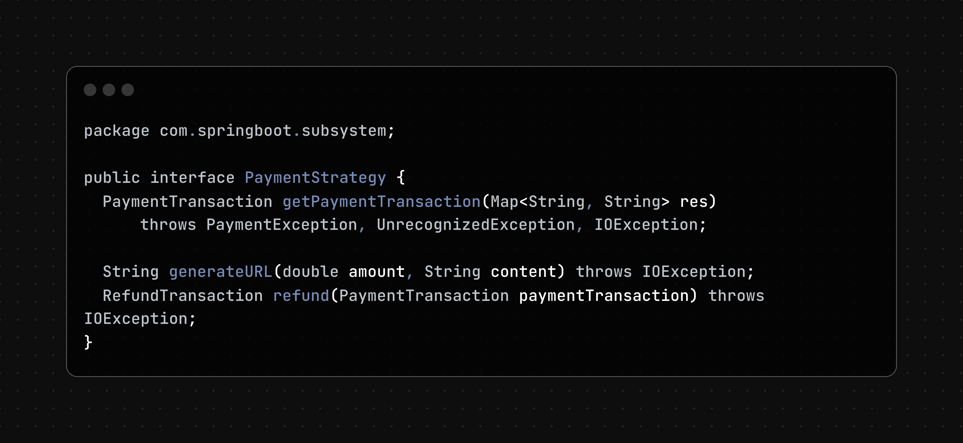

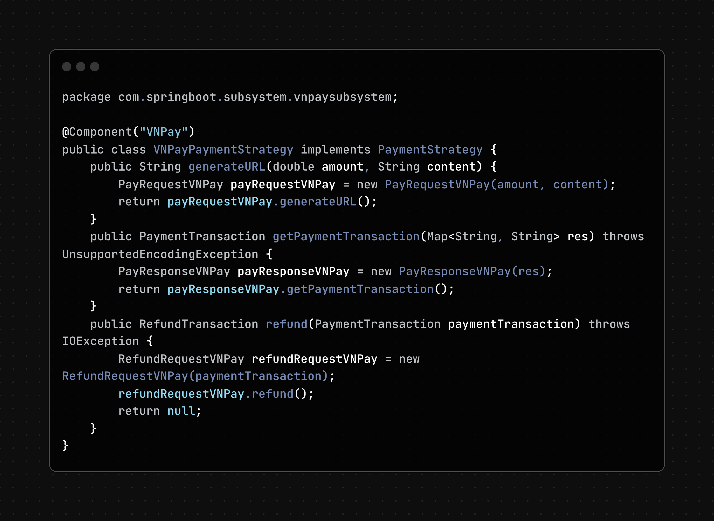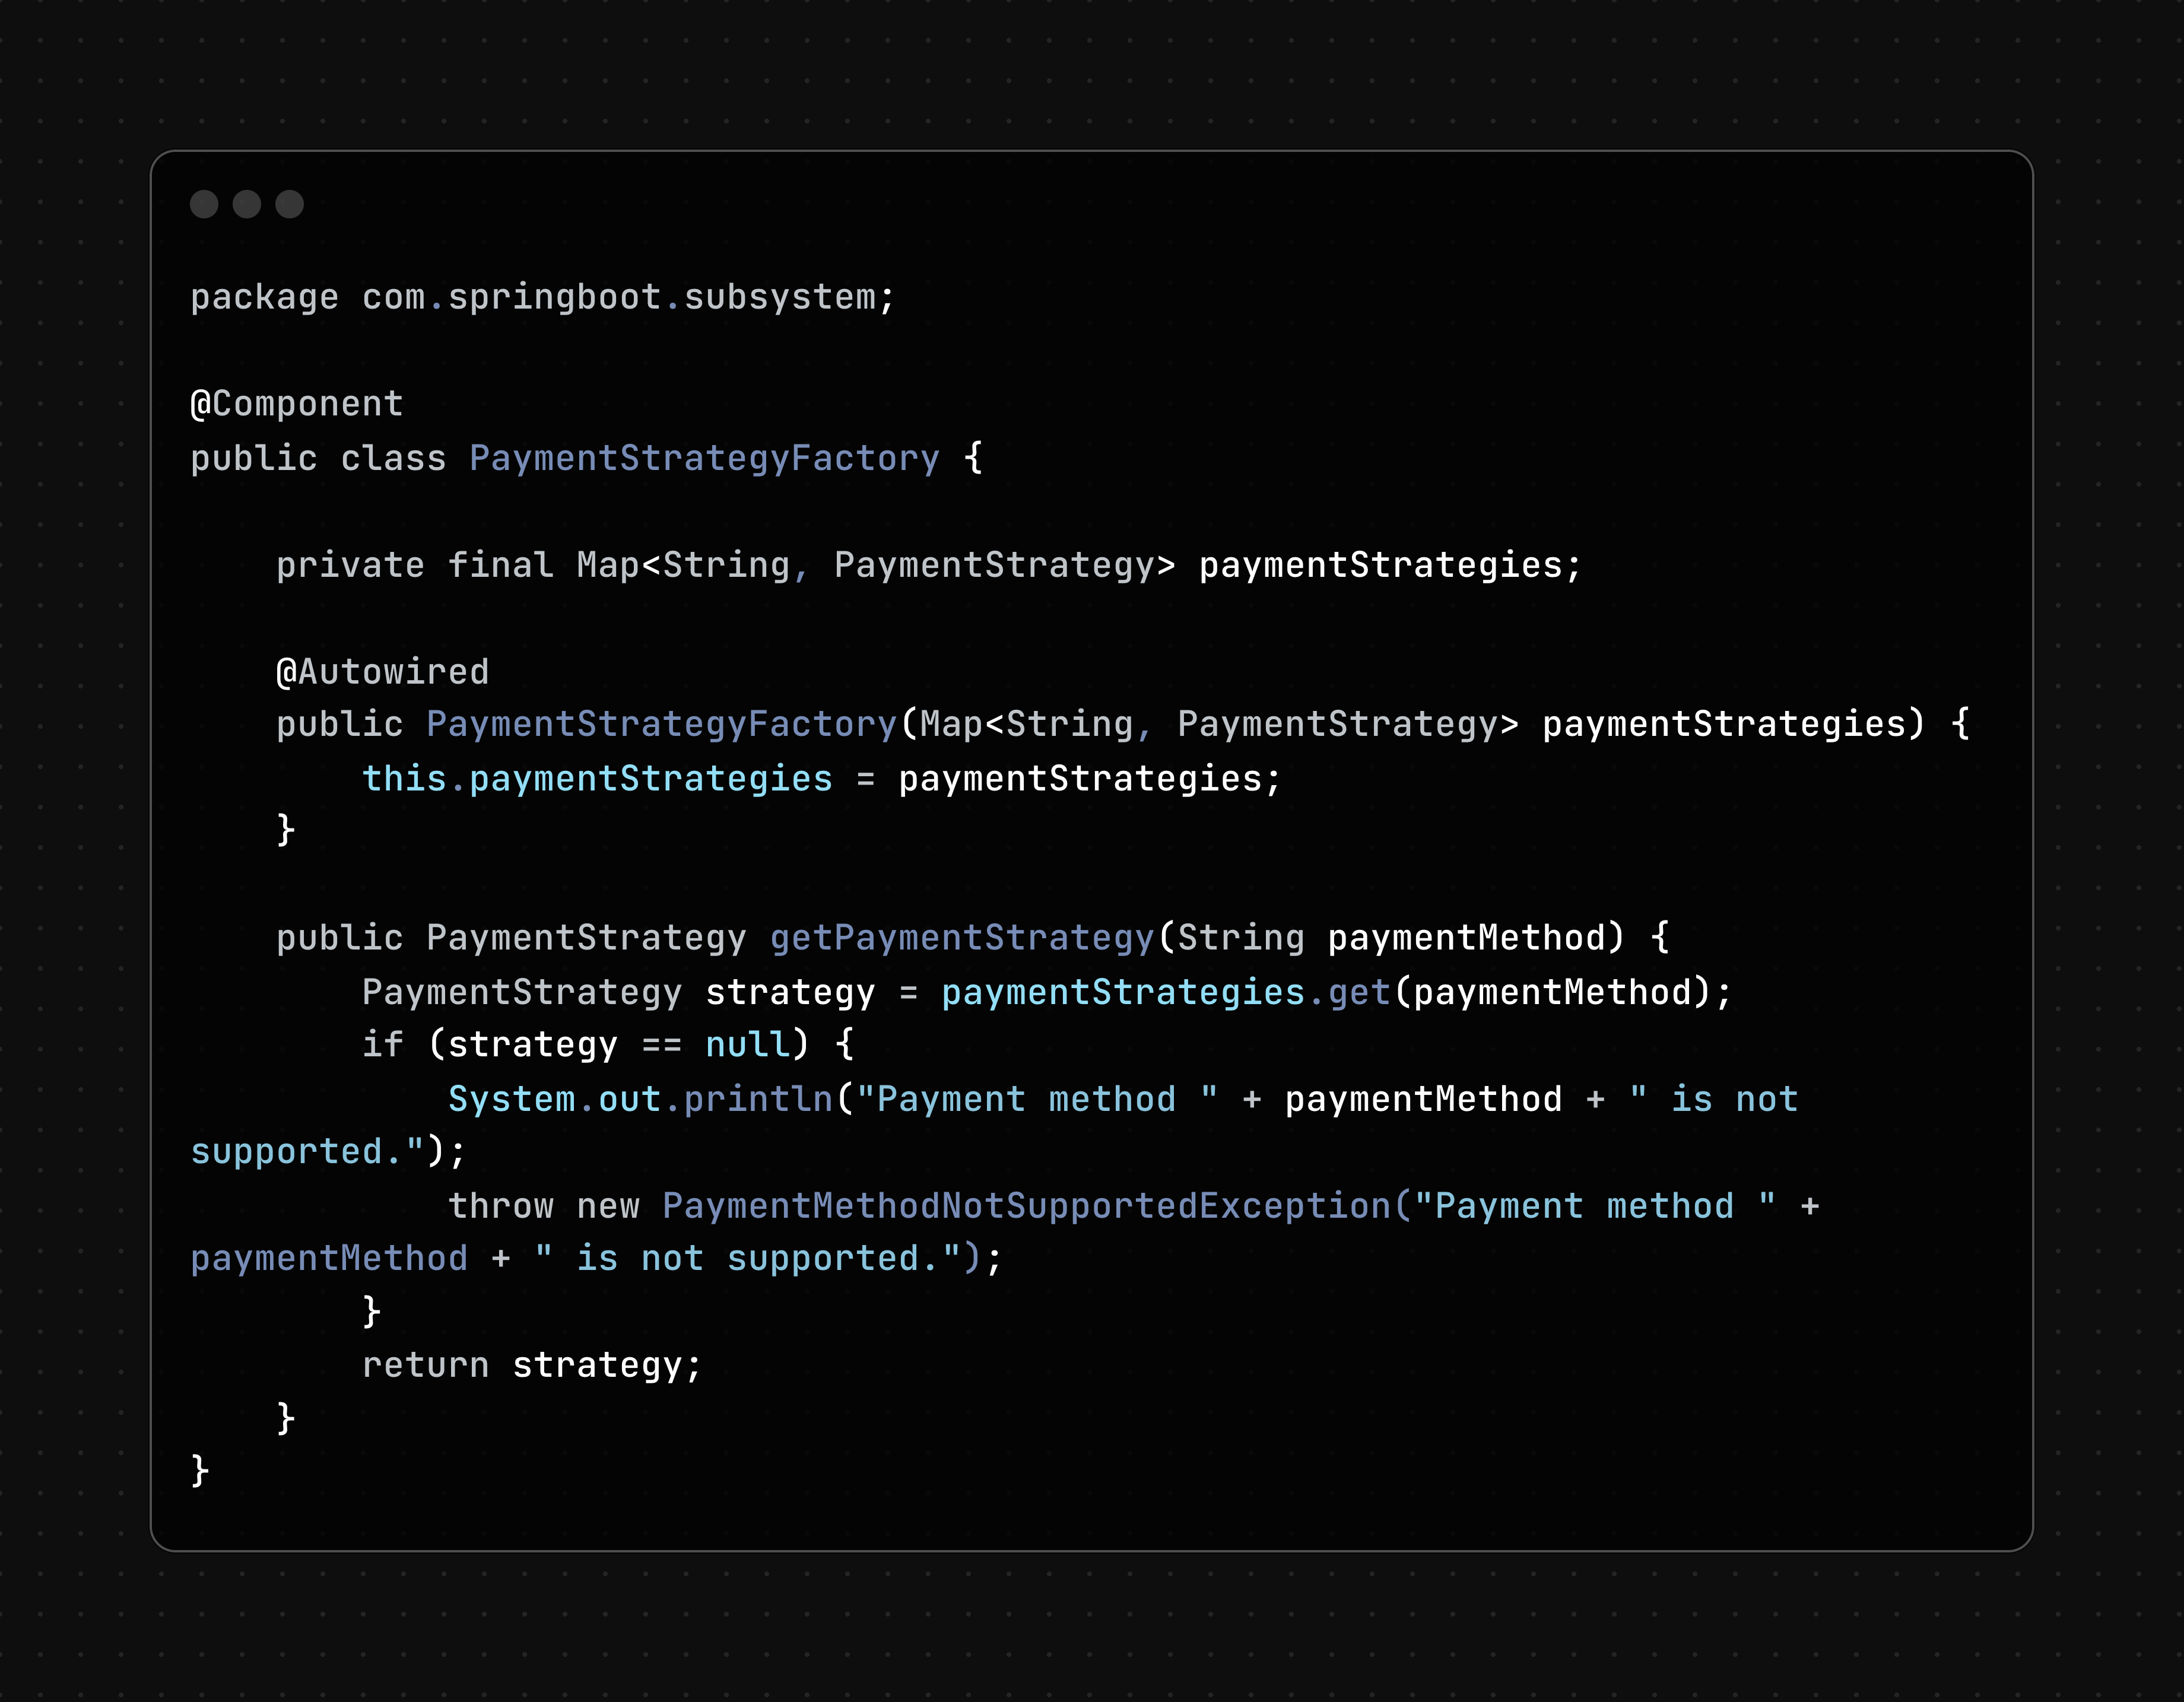

**Benefits**

Using the Strategy Pattern allows us to flexibly add new payment methods without altering the existing code structure. The payment process remains streamlined from backend to frontend, with changes only required in configuration files or frontend systems.

### Builder Pattern

The Builder Pattern is a creational design pattern that allows constructing complex objects step-by-step. It provides a way to create objects with a large number of parameters or complex configuration in a readable, maintainable, and flexible manner.

In our e-commerce project, we need to support multiple payment systems, which may return data in various formats. This variety can complicate the payment construction method, making it too lengthy and inflexible for future changes. To address this, we use the Builder Pattern.

**Implementation**

We leverage Lombok, a Java library that provides automatic generation of boilerplate code, to implement the Builder Pattern. This ensures our code remains clean and easy to maintain.

* **Define the Payment Object**: Use Lombok annotations to create a builder for the payment object.
* **Initialization**: Initialize the payment object in a way that is clear and comprehensible to developers.

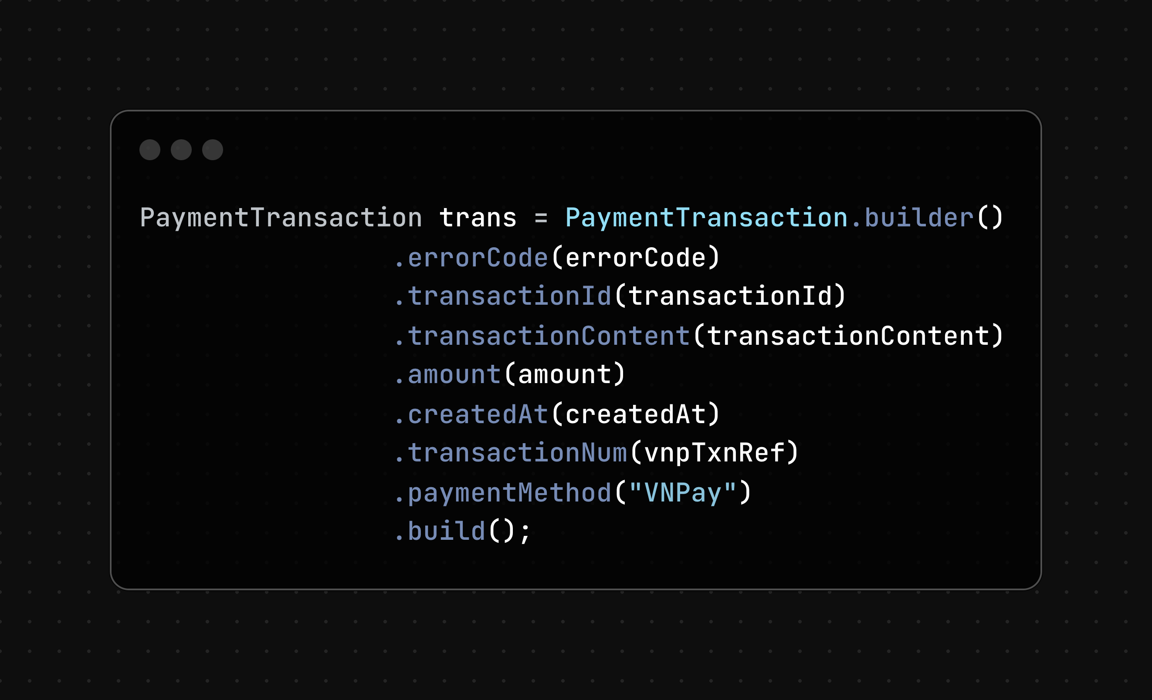

**Benefits**

Using the Builder Pattern allows us to handle complex object construction in a flexible and readable way. This pattern ensures that our code is maintainable and can accommodate future changes easily. We can confidently integrate new payment systems and handle varied response data formats without making the codebase troublesome or error-prone.